Two-Thirds of the World Faces Severe Water Shortages

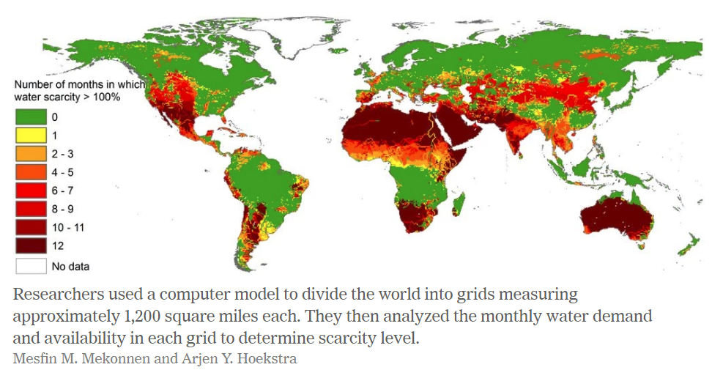
By Nicholas St. Fleur
Feb. 12, 2016

About four billion people, or two-thirds of the world’s population, face severe water shortages during at least one month every year, far more than was previously thought, according to Arjen Y. Hoekstra, a professor of water management at the University of Twente in the Netherlands.
In a paper published Friday in the journal Science Advances, Dr. Hoekstra and his colleague Mesfin M. Mekonnen designed a computer model to create what they say is a more accurate picture of water scarcity around the world. Severe water scarcity can lead to crop failure and low crop yields, which could cause food price increases as well as famine and widespread starvation.
An area experiences severe water scarcity when its farms, industries and households consume double the amount of water available in that area.
“That means that groundwater levels are falling, lakes are drying up, less water is flowing in rivers, and water supplies for industry and farmers are threatened,” Dr. Hoekstra said in an email.
Not everyone would suffer equally. In more affluent countries, severe water scarcity could mean water rations for showering and gardening, while in very poor countries it could lead to shortages of drinking water.
Half of the four billion people who experience conditions of severe water scarcity at least one month of the year live in either China or India, Dr. Hoeskstra said. Of the remaining two billion, the majority live mostly in Bangladesh, Pakistan, Nigeria, Mexico and the western and southern parts of the United States, such as California, Texas and Florida.
Previous studies had estimated that between 1.7 and 3.1 billion people were affected by extreme water shortages. But according to Dr. Hoekstra, those studies either used measurements that were too general in size or used yearly averages that were not as precise as monthly data.
“Freshwater scarcity is a major risk to the global economy, affecting four billion people directly,” Dr. Hoekstra said. “But since the remaining people in the world receive part of their food from the affected areas, it involves us all.”

https://www.nytimes.com/2016/02/13/science/two-thirds-of-the-world-faces-severe-water-shortages.html

