Reaction Report #5
June 21, 2013

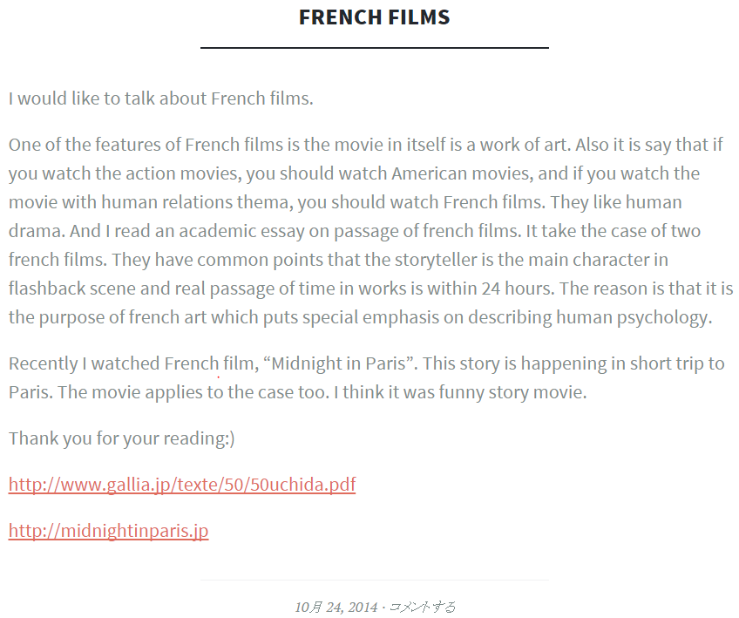

Note: This is from a student blog. If you would like to write your reaction reports as a blog, you would simply need to send your blog URL to me.

