**Teddy Bears**

**(Group Research Project Preliminary Report)**

Taro Suzuki, Takashi Yamamoto, Hiroshi Tanaka, Daisuke Matsuzaka

English 1D

Dr. Elwood

December 20, 2013

**Group members**

Our group members are Student 1, Student 2, Student 3, and Student 4.

**Topic and Rationale**

We have decided to do our research project about stuffed animals and, more specifically, about teddy bears. We chose this topic because all of our members like … In addition, we suspect that teddy bears in different cultures might …

**Methodology**

We are planning to our research in two stages. First, we will carefully search for background information about teddy bears using the university library and the Internet. We also will take pictures of the various teddy bears that we have. In the second stage we are planning to interview people from different countries about several points. These points include what kinds of stuffed animals people have in each respective culture, how …

We have several people in mind for interviews. First, we hope to talk with our high school English teachers. Second, we are planning to talk with some of the international students of Dr. Elwood. Finally, we also hope to talk with some of the international students at Meiji University. We anticipate interviewing 15-20 people.

**Results**

The first phase of our research about teddy bears consisted of collecting information from two primary sources, the Internet and the library. We conducted an extensive search of teddy bear materials on the Internet and found …

We also visited the university library and searched for teddy bear material. We found six books that dealt with teddy bears, the most helpful of which was a volume on the history of stuffed animals (Brown, 2007). This 350-page book detailed the history of …

The second phase of our research includes interviews with people related to teddy bears. Our first interview was with Professor Clarene Smith of the Literature Department of Meiji University. She is an expert on …

We have not yet interviewed the remaining three people that we would like to. These three people are Professor Cyrus Vance of the History Department at ABC University, Professor … We are planning to speak with Professor Vance on January 15, 2014, at his office at ABC University. However, we are still trying to schedule a meeting with Professor Midas Moose.

**Internet Report**

We have created a blog to present our project results. The blog is titled “Teddy Bears Forever” and is located at http://teddybearsforever.wordpress.com. To date we have six pages, numerous posts, and a total of 15 photographs. We are also planning to include a video of the teddy bear exhibition at the New Museum of Modern Art, which is being held from January 7 to February 24, 2014.

Below is a screenshot of our blog.

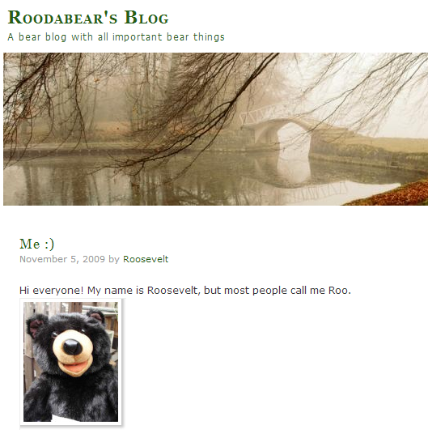

**References**

Brown, R. (2007). *A concise history of stuffed animals.* London: Furry Publishing, Inc.

Madison, J. W. (2013). A cross-cultural comparison of teddy bears and their roles in conflict mediation. Retrieved November 20, 2013, from http://www.polisci.furryuni.edu/madison

Vance, C. (2010). The history and glamour of teddy bears. *Journal of Virtual Reality, 15*(2), 35-51. Doi: 10.4545.jvr.15.2.vance