Souvenirs
(Group Research Project Preliminary Report)

Student Name & Student Name

English 1D
Dr. Elwood

November 30, 2019

Group members
Our group members are [student name] and [student name].
Topic and Rationale
We have decided to do our research project about various souvenirs around the world and, in particular, about kinds of souvenirs. We chose this topic because we had no idea what to buy as souvenirs of our trip when we went to abroad. In addition, we wanted to learn about the history of souvenirs in America, Europe, and Japan (Tokyo and our hometowns, where are Kanagawa and Miyagi),.
Methodology
We are planning to do our research in third stages. First, we carefully searched for background information about souvenirs using the university library and the Internet. We also read Tourism magazine; these results are reported in the next section. In the second stage we visited the Asakusa area and investigated what visitors buy there. We recorded the interviews with a video camera and will edit them into a video for our final presentation. We were able to interview 14 people, of whom six were from France, three from Canada, and five from the US.
In the third stage we are planning to go shopping at two import shops, Import Pier in Shibuya and Straight Off The Ship in Yokohama. Both of these stores carry many products from around the world.
Results
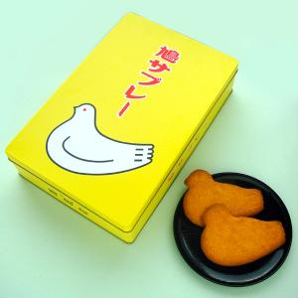
The first phase of our research about world souvenirs consisted of collecting information from two primary sources, the Internet and the library. We conducted an extensive search of world souvenir materials on the Internet and found that there is too many information to search so we decided to examine the kinds and history of souvenirs in North America and Europe and Japan.
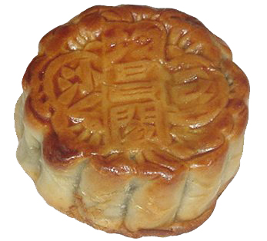
We listed up souvenirs of our respective hometowns, Kanagawa and Miyagi. First, Kanagawa is known for hatosabure, which is a cookie shaped like a pigeon (in the picture to the right). It is a hard, crunchy treat that is best eaten with a cup of tea of coffee. The second souvenir is called geppei, which is a kind of Chinese cake (in the image to the left). In English it is known as a mooncake, and it is traditionally eaten during the Mid-Autumn Festival, which is about viewing and appreciating the Moon. Mooncakes are filled with sweet bean paste and walnuts, and they are best served with green tea.
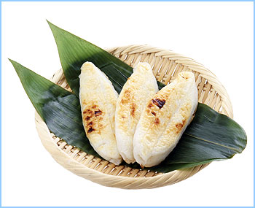
Miyagi is famous for four kinds of souvenirs, three of which are food. The first is sasakamaboko (bamboo-grass kamaboko). This is boiled fish paste and the shape is like bamboo (in the image to the right). The second is gyutan, which is beef tongue. It is grilled over charcoal and often served oxtail soup and mugi gohan (steamed white rice with barley). In its donburi variety, gyutan is served over a bowl of steamed white rice, while the curry gyutan is accompanied by rice as well. The third dish is zunda, which is a paste of boiled soybeans with sugar. We often eat it with rice cakes.
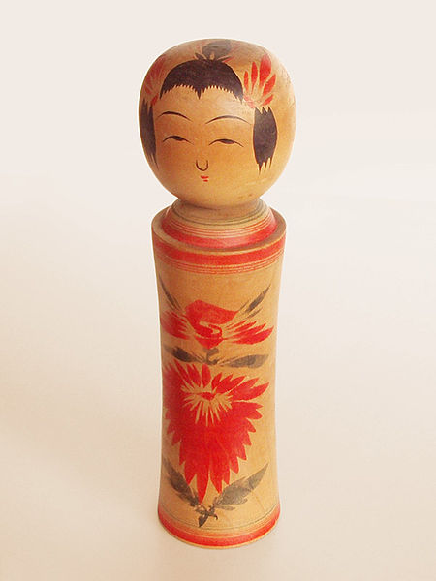
The final Miyagi souvenir is kokeshi, which are Japanese dolls. These are originally from northern Japan and are handmade from wood. Typically they have a simple trunk and an enlarged head with a few thin, painted lines to define the face (see the picture to the right).
We also visited the university library and searched for souvenirs of travel. We found three books that dealt with travel. These books were written about souvenirs of Florida and southern USA, California and the Coast, Rocky Mountain and the West, New York and the East, Great Lakes and Midwest, United Kingdom, France, Belgium, Netherlands, Germany and Italy.
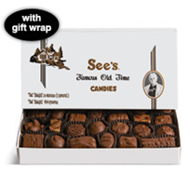
Souvenirs in America were from five different areas. First, Florida and southland have a food culture that is different from those in other areas because there are many spicy foods in the southland. Thus, you can buy recipe books and instant foods as souvenirs, and you can find original goods in Orlando in Florida. The second area is far away, California and the west coast. Chocolates including See’s Candies are famous as souvenirs in California. In Seattle and Portland, goods on sale in chain cafes would be good. Also, playing cards used in casinos are sold in Las Vegas.
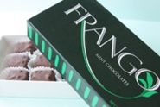
The third area is the Rocky Mountains and the West, where we find various souvenirs in each town. You should buy items for cowboys in Fort Worth, and foods prepared for astronauts in the Space Center in Houston. Next is New York and the East, where, needless to say, you should keep it in mind to buy items about the Statue of Liberty in New York. Finally, we have the Great Lakes and the Midwest. There are souvenirs based on specialties and industrials in each town. In Chicago, you can buy good chocolates. Chicago is the cradle of Frango, which is a peppermint chocolate [1].
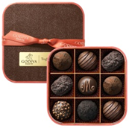
Souvenirs in Europe are, of course, also very interesting and varied. In the United Kingdom, simple and convenient souvenirs such as tea and tea sets are popular. Paddington Bears and goods decorated with union Jack are so pretty. In In Provins in France, Marseille soaps and clothes which are Provins-print are famous. In Cote d’Azur, perfumes made in Grasse or potpourri, Limogesware and Quimperware, and glass tableware made of Cristals in Baccarat. Belgium is famous for chocolates, which are so famous on a global scale (photo to the right). GODIVA and neuhaus are familiar in Japan. Also Belgium is famous for diamonds, but they are so expensive. Thus, why don’t you buy lace, which is a Bruges product?
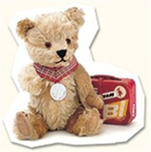
The Netherlands features many pretty dolls in ethnic costumes. A snugglebunny Miffy is from Netherlands. Germany also dolls made of woods, which are typical of Germany. Moreover, original teddy bears are made here by Steiff. They are beloved around the world because they are so pretty.
Italy, too, has wonderful souvenirs. The picture frames and accessories made of Venetian classes are accessible and easy to carry around. You should also find leather goods and jewelry in Firenze.
The second phase of our research includes interviews with people who are traveling at Asakusa. We went to Asakusa and interviewed 14 foreign citizens and asked people what they bought there. They had bought figures of Mount Fuji, things which are of classic Japanese design, dried laver seaweed, and postcards of Japanese graphics.
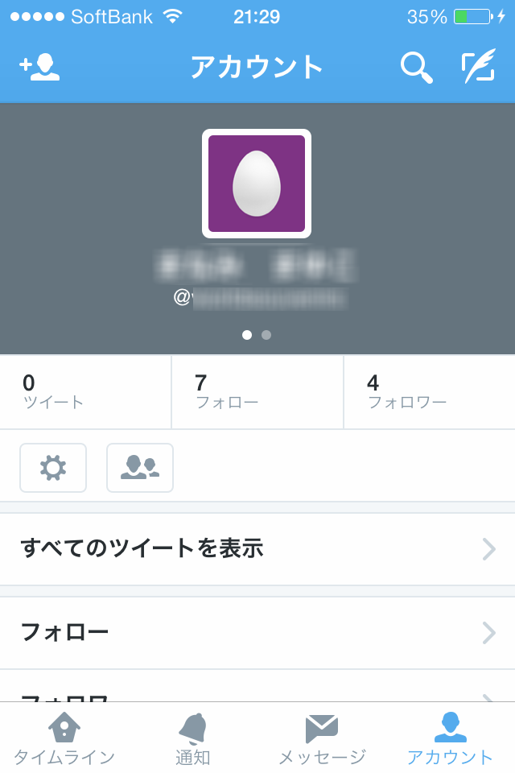
Internet Report
We have created an account of twitter to present our project results. Our twitter account name is *********, which is located at https://twitter.com/**********. We have not done tweeting so much yet so we are going to tweet more.

References
Hatosabure. (n.d.). Retrieved November 20, 2013, from http://www.hato.co.jp/hato/
Kotobank. (n.d.). Retrieved November 20, 2013, from http://kotobank.jp/%E6%9C%88%E9%A4%85
Maeda, H. (2008). Chikyu-no-arukikata B01 America. Tokyo: Diamond Big, Inc.
Sendai-omiyage express. (n.d.). Retrieved December 20, 2013, from http://www.sendaimiyage.com/about/ranking.html
Suzuki, H. (2010). Chikyu-no-arukikata A01Europa. Tokyo: Diamond Big, Inc.

