Movies

(Group Research Project Preliminary Report)

Student 1, Student 2, Student 3, and Student 4

English 1D

Dr. Elwood

November 30, 20##

Group members
Our group members are John Suzuki, Mike Suzuki, Rob Suzuki, and Dane Suzuki.

Topic and Rationale
We have decided to do our research project about various movies and movies around the world, in particular about kinds of movies all over the world. We chose this topic because movies are popular around the world and we became interested in the difference of world movies. In addition, we wanted to learn about not only kinds of movies all over the world but also history of movies.

Methodology
We are planning do our research in two stages. In the first stage, we searched for background information about movies such as the history of movies and increasing the number of watchers using a subscription instead of not going to the movie theater. In the second stage, we did research by using the Internet and a questionnaire for 100 people on Twitter and Instagram. On SNS, we collected information not only from the same university students but also people of all ages. We prepared eight interview questions on the questionnaire; the results of them are shown below.

Results
We reported the results of history and using subscription, which are background information about movies.

1. History of the movie
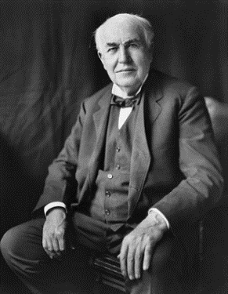
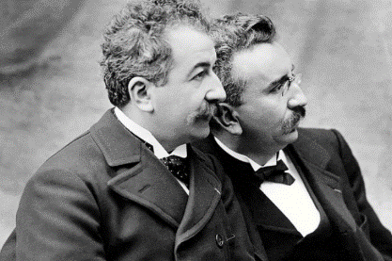
In the late 19th century, Edison released an automatic video vending machine. After that, the Lumiere brothers of France invented a way to project it on a screen. This was the historic moment of the beginning of movies. In Japan, the first domestic film was released in 1908 and the first movie theater was created. Then, in the 1950s, it was finally possible to shoot color moving images with a single film. In the 1970s, color films became mainstream. In Japan, the first color film was released in 1951, a movie called “Carmen returns home”. Movies became increasingly popular and then widely established as people’s entertainment in the 1970s. Today, there are a lot of kinds of movies all over the world. The nature is various by country, where it is influenced by culture and nationality.
The countries that are famous for movies are the U.S (Hollywood), Japan, India and Korea. Hollywood’s movies are considered to be the best in the world. They can make so many people excited. Japan’s movies have high quality animation skills and are popular due to them. India’s movies are unique because actors tend to dance in them because of religious views. Korea’s movies tend to express human dramas and they are more impressive than other countries. There are many types of movies, such as action movies, adventure movies, documentary movies, drama movies, family movies, fantasy movies, war movies, and western movies. Furthermore, many kinds of movies are enjoyed by many people in various places.
2. The way of watching the movie
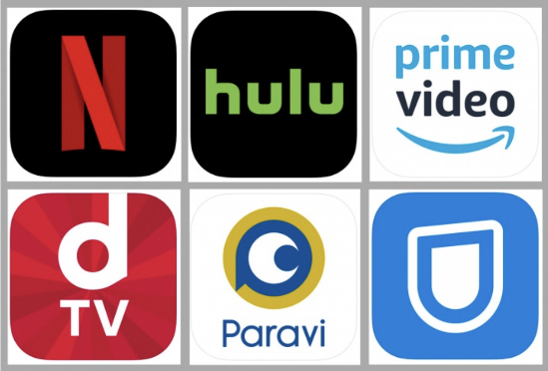
Today, a lot of people watch the movie anywhere and anytime because the number of the people who use a subscription service has increased. People watch movies which are, for example, old movies, movies that were missed, and niche movies. We had to stay home expect for essential needs cases during the Covid-19 pandemic, so people increasingly turned to subscription services because we had too much time. Also, the picture quality and sound quality is developed recently. We are able to enjoy watching movies without going to the movie theater. However, we have to go to the movie theater to watch the latest movie, so we can not necessarily watch all movie with the subscription. According to the Motion Picture Producers Association of Japan, the number of the people who go to the movie theater has not decreased. A lot of people enjoy watching movies through some way.

3. Results
We researched how people enjoy moves and by using questionary. We were able to interview more than 100 friends by using Instagram or Twitter and we considered how people enjoy movies recently.
First, we researched how movies “How do you watch movies?” choices: theater, Amazon Prime, Netflix or Hulu, by using the questionnaire function on Instagram. 160 people answered. As a result, we found that 34% people use theater to see movies and 26% use Netflix, 36% use Amazon Prime. In other words, about 70% people use subscription service to see movie. We thought there is the background that there is the spread of smartphone, internet and covid19 so they tend to want to enjoy watch movie at home.
Second question is “Which do you want to watch foreign movies with subtitle or dubbing?”. We found that 83% people watch them with subtitle and that 15% people watch them with dubbing. We thought why people most like to watch foreign movies with subtitle. We have three reasons. First, we think that most people like how to express emotions in away unique to foreign countries. By translating into Japanese, the meaning of some phrases in foreign languages changes different meaning rarely. Second, some people say that they want to enjoy the voices and performances of foreign actors. If they watch foreign movies with dubbing, they end up with hearing the voices of Japanese actors. They can only enjoy content of the movies. Third, it is said that it is easy to be impressed on their memory by watching performance and reading the subtitle. We think that it is helpful for people who want to understand content of foreign movies deeply.
Third, we researched “Which countries movies do you like? Korea, India, Japan, the U.S”, and we found that 58% people like Japanese movies, 23% people like America (Hollywood) movies and 8% people like Korean movies. People tend to like the movies of their own countries because they can understand story easily.
Forth, we researched “Which movies do you like better, old ones or new ones”. We found that 74%people like old movies better. The reason is because recent movies have the same sensibility as recent people. So, they can understand movies and the backgrounds easily.
According to second, third, and fourth research, we think people want to understand the contents of movies because domestic languages, actor’s voice and face, and close sensibility make people understand them easily. In seeing foreign movies, foreign letters do it too. If we can’t understand contents of a movie, we will think it is boring.
The next research is “How often do you watch movies?”. We found that 63%people see foreign movies once per a month, and 21%people twice or three times per a month. There are only 8% people who see movies every day. They answered there isn’t much time to see a movie every day or they don’t want to spend money and go to theater. It may be just right to see a movie once a month.
The next question is “What kind of movies do you like?” As a result, 57 people liked action movies. Another 26 people said they like comedies. And there was only one person who answered that he likes horror. When I actually asked them, they said he likes cool movies like Avengers. On the contrary, horror is scary and I don’t want to see it. From these things, it turned out that cool action movies are especially liked.

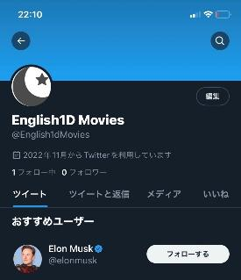
Internet report
We have created a Twitter account to present our project results. Our Twitter account name is English1D Movies, which is located at [url here]. We have not done tweeting so much yet so we are going to tweet more.

References
History of movies.(n.d.). Retrieved November 29, 2022, from 映画の歴史 (e-eiga.net)
LUCKY NOW. (2016). Retrieved November 29, 2022, from https://luckynow.pics/world-film/
Movie’s statistics. (n.d.). Retrieved November 28, 2022, from www.eiren.org/toukei/data.html
Screen Online. (n.d.). Retrieved November 29, 2022, from https://screenonline.jp/_ct/17451588

