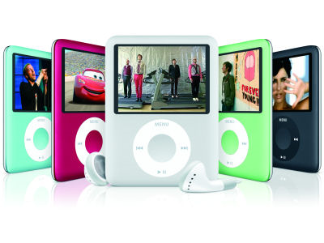In our next couple classes this term we’ll be talking about the Internet and computers (also similar devices). Let’s consider such things in more detail

1. List all the e-communication devices you use (e.g., cell phone, iPod, PC).

2. Now list all the types of tasks you do (e.g., doing e-mail, making documents).

3. List the time you spend on each type of task (per week).

4. Have ICT devices made your life better? Easier? More convenient? In what ways?

5. Imagine giving up your cell phone for one week. Could you do so? Why or why not?

6. In 2008, Nicholas Carr wrote a thought-provoking essay titles “Is Google Making Us Stoopid?” Why might he have asked that question? (In other words, why is Google perhaps making us stupid?)

7. Your opinion: I think the Internet (Google, ICT) is making people _____________ because …

8. With your neighbors, discuss your opinion and their opinion.

9. As you’ll know from our class discussion, your homework this week is to read (or watch) the Carr article, the Shirky article, or the Reilly video and text; thereafter you’ll write a summary of the article and your reaction to it.

