Creation of Moai

Taro Suzuki & Hiroki Tanaka

English 1C
Dr. Elwood

July 14, 2014

We decided to report on moai, large stone statues from Easter Island. In the movie “Night at the Museum” a moai in the American Museum of Natural History plays a small but important role, and we would like to explain various features of moai in this report.

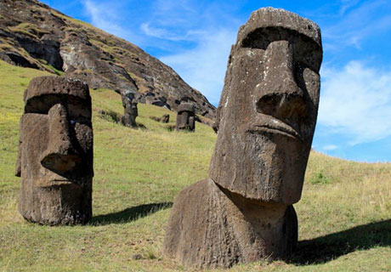
What are moai?
Moai are stone statues which have a man-like face. They are found on Easter Island, which is located in the south of the Pacific, around 3,500 kilometer away from central Chile. Most of moais are about 3.5 meter tall and weigh 20 tons. The biggest statues are 20 meter tall, and weigh 90 tons. The number of the statues is about 1,000, including the ones that were not completed. Moais are protected legally. If you destroy or paint the statues, you can be arrested.
Why were moai made?
There are many opinions. Some researchers say that they were made for ritual and others say that they are the gravestones. In fact, this reason is not known, because there are little data about moai except statues of its. The only clue is the hieroglyphic symbols called Rongorongo. They were used on Easter Island and written on stone boards. It is believed that there were many stone boards in the past but the Europeans who invaded Easter Island destroyed them. There are only 24 boards now, so the decipherment of its is not making progress. The reason why moai were made will be known only when Rongorongo is deciphered.
Moai Construction
One of the theories about when building moais started says that it happened around the 7th to 10th Century AD. People who are called Rapa Nui cut stones from quarries to build moais, the Easter Island statues. The quarry people often used in the Easter Island is Rano Raraku, where they shaped and transformed the stones into the Easter Island statues. Otherwise, people moved the stones to another place, made moais, and finally arranged the statues around the island. Thus, we have one question: how did people on the island carry such heavy stones all over the island? Researchers consider that workers used levers and rollers to carry heavy stones. Now there are no forests for rollers, but their geologic survey proves that palms existed on the island hundreds years ago.
References
Easter Island rykouki. (n.d.). Retrieved July 11, 2014, from http://www.asahi-net.or.jp/~br4t-ickw/easter_5.htm
Fushigi mystery 100renpatsu! doudamaittaka! (n.d.). Retrieved July 11, 2014, from http://blog.goo.ne.jp/100renpatu/e/abc7e390a2ee17a4f1f463b3700fe1a1
mikakunin seibutsutairiku” (n.d.). Retrieved July 14, 2014, from http://www.never-world.com/contents/mystery/moai.html

