Database Search: Boolean Operators

Boolean operators form the basis of mathematical sets and database logic. They connect your search words together to either narrow or broaden your set of results.

The three basic Boolean operators are: AND, OR, and NOT.

Why use Boolean operators?

* To focus a search, particularly when your topic contains multiple search terms.
* To connect various pieces of information to find exactly what you're looking for.

Example:

second creation (title) AND wilmut and campbell (author) AND 2000 (year)

Using AND

Use AND in a search to:

* narrow your results
* tell the database that ALL search terms must be present in the resulting records

example: cloning AND humans AND ethics

The purple triangle in the middle of the Venn diagram below represents the result set for this search. It is a small set using AND, the combination of all three search words.

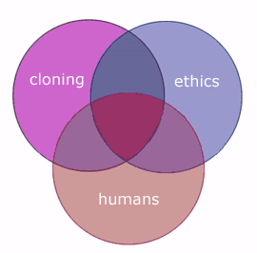

Be aware: In many, but not all, databases, the AND is implied. For example, Google automatically puts an AND in between your search terms.

Though all your search terms are included in the results, they may not be connected together in the way you want. For example, this search: college students test anxiety is translated to: college AND students AND test AND anxiety. The words may appear individually throughout the resulting records.

You can search using phrases to make your results more specific.

For example: "college students" AND "test anxiety". This way, the phrases show up in the results as you expect them to be.

Using OR

Use OR in a search to:

* connect two or more similar concepts (synonyms)
* broaden your results, telling the database that ANY of your search terms can be present in the resulting records

*example: cloning OR genetics OR reproduction*

All three circles represent the result set for this search. It is a big set because any of those words are valid using the OR operator.

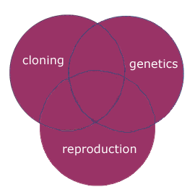

**Using NOT**

Use NOT in a search to:

* exclude words from your search
* narrow your search, telling the database to ignore concepts that may be implied by your search terms

example: cloning NOT sheep

Search order

Databases follow commands you type in and return results based on those commands. Be aware of the logical order in which words are connected when using Boolean operators:

Databases usually recognize AND as the primary operator, and will connect concepts with AND together first.

If you use a combination of AND and OR operators in a search, enclose the words to be "ORed" together in parentheses.

Examples:

ethics AND (cloning OR reproductive techniques)

(ethic* OR moral*) AND (bioengineering OR cloning)

TRUNCATION

Root words that have multiple endings: sun = suns, sunshine, sunny, sunlight

Words that are spelled differently, but mean the same thing: color, colour

Truncation/wildcard symbols vary by database. Check the help screens to find out which symbols are used.

About truncation and wildcards

Truncation:

Truncation, also called stemming, is a technique that broadens your search to include various word endings and spellings.

To use truncation, enter the root of a word and put the truncation symbol at the end.

The database will return results that include any ending of that root word.

Examples:

child* = child, childs, children, childrens, childhood

genetic* = genetic, genetics, genetically

Truncation symbols may vary by database; common symbols include: *, !, ?, or #

Wildcards:

Similar to truncation, wildcards substitute a symbol for one letter of a word.

This is useful if a word is spelled in different ways, but still has the same meaning.

Examples:

wom!n = woman, women

colo?r = color, colour

PROXIMITY OPERATORS

Proximity operators

Many databases allow you to specify that the words you are searching are within a certain proximity of each other.

Proximity operators are more specific than Boolean operators and make your search more precise.

Proximity operator examples

Proximity operators also vary by database, but some common ones include:

w# = with

*With* specifies that words appear in the order you type them in.

Substitute the # with a number of words that may appear in between. If no number is given, then it specifies an exact phrase.

Examples:

genetic w engineering (searches the phrase genetic engineering)

Hillary w2 Clinton (retrieves Hillary Clinton, Hillary Rodham Clinton, etc.)

n# = near

***Near*** specifies that the words may appear in any order.

Substitute the # with a number of words that may appear in between.

Examples:

cloning n3 human (retrieves cloning of humans, human cloning, etc.)

Mostly from http://libguides.mit.edu/c.php?g=175963&p=1160724