Class #1

February 7, 2013

Course introduction

Virtual Magnifying Glass

APA = American Psychological Association

(in text)

Table: text or numbers

Figure: images, maps, …

Appendix: at the end of the paper … supplementary material

As you’ll have noticed in the syllabus, I included Occam’s Razor. Why might I have done so?

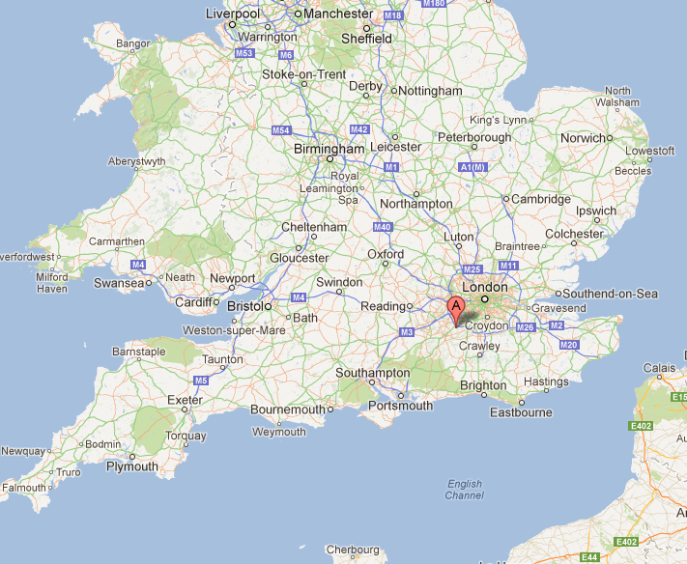

William of Ockham (ca. 1285–1349)

philosopher

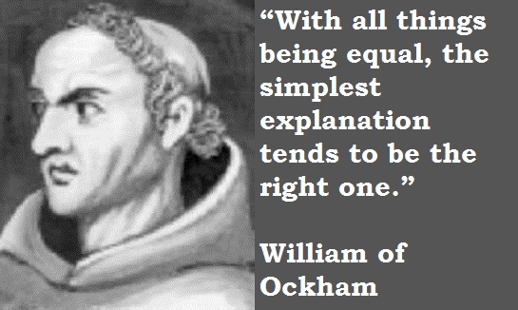



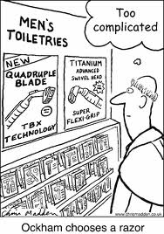

*[Numquam ponenda est pluralitas sine necessitate](http://en.wikiquote.org/wiki/William_of_Occam" \o "q:William of Occam)* [Plurality must never be posited without necessity],

(Often) Simpler is better.

*But not too simple!

1. Briefly introduce your table / figure.
2. Good? Effective?
3. How would (could) it be improved?

Your homework this week: find, copy, and bring a table (any table) to class next week. You will be analyzing and explaining it during class.

A hint: As with all things, being parsimonious is a good idea (ask our friend, William). If you have a table from your own research or from some related literature, by all means bring that!