Class #4

March 7, 2013

Good afternoon, everyone, and welcome to March (or, as we all probably hope, WARM March!). Today I’d like to begin with a bit of review since it has been two weeks since we’ve met … Please take a good look at Table 1 and note changes (mistakes) …

Can you suggest any changes that would help your reader understand more easily?

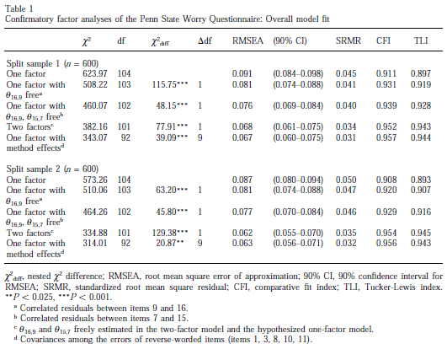

A question: how can you keep a table from splitting across a page division?

Under paragraph, on the second tab click “Keep with next”

Next, let’s fix Table 1 ☺

|  |  |  |  |  |  |  |  |
| --- | --- | --- | --- | --- | --- | --- | --- |
| Table 1  Confirmatory factor analysis of the Penn State Worry Questionnaire: Overall model fit | | | | | | | |
|  | χ2 | df | | χ2diff | Δdf | RMSEA |  |
| *Split sample 1 (n = 600)* | | | |  |  |  |  |
| One factor | 623.97 | | 104 |  |  | 0.091 | 0.897 |
| One factor with Θ16,9 free | 508.22 | | 103 | 115.75*** | 1 | 0.081 | 0.910 |
| One factor with Θ16,9 Θ15,7 free | 460.07 | | 102 | 48.15*** | 1 | 0.076 | 0.928 |
| Two factors | 382.16 | | 101 | 77.91*** | 1 | 0.068 | 0.943 |
| One factor with model effects | 343.07 | | 92 | 39.09*** | 9 | 0.067 | 0.944 |
| *Split sample 2 (n = 600)* | | | |  |  |  |  |
| One factor | 573.26 | | 104 | 115.75*** |  | 0.091 | 0.897 |
| One factor with Θ16,9 free | 510.06 | | 103 | 48.15*** |  | 0.081 | 0.910 |
| One factor with Θ16,9 Θ15,7 free | 464.26 | | 102 | 77.91*** |  | 0.076 | 0.928 |
| Two factors | 334.88 | | 101 | 39.09*** |  | 0.068 | 0.943 |
| One factor with model effects | 314.01 | | 92 |  |  | 0.067 | 0.944 |
| χ2diff, nested χ2 difference; | | | | | | | |

Control + D = font window

Titles of tables – like Goldilocks ☺



OK, let’s attempt a table title … you want to show the relationship between the majors that students have (psychology, physics, English, and engineering) and their respective performance on the three different tests (Test A, Test B, and Test C).

Table 1

*Relationship between College Majors and Performance*

Table 1

*Mean Performance Scores on Test, A, Test B, and Test C of Students with Psychology, Physics, English, and Engineering Majors*

Table 1

*Mean Test Performance Scores of Students with Different College Majors*

Let’s practice some, shall we?

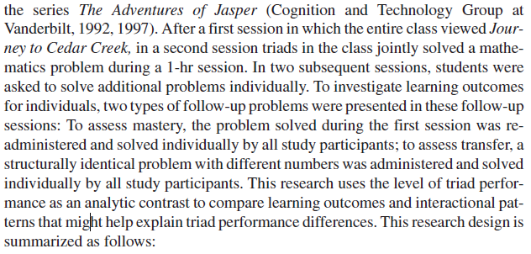

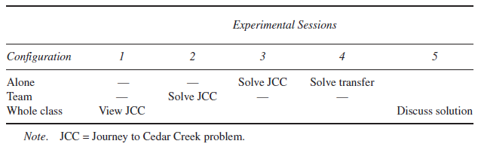

One mistake, however …

From Major et al. (1997), p. 1355:

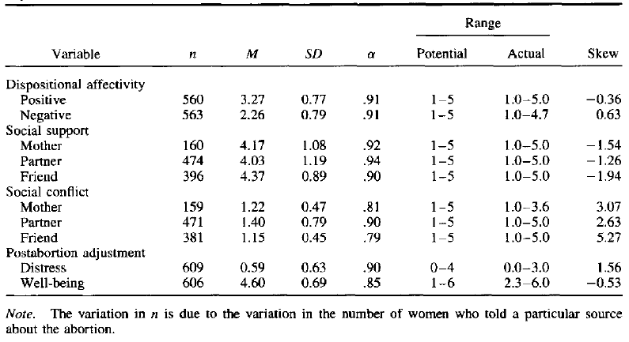

What is a good title for the table below from Barnette (2000, p. 365)?

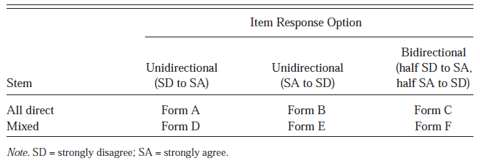

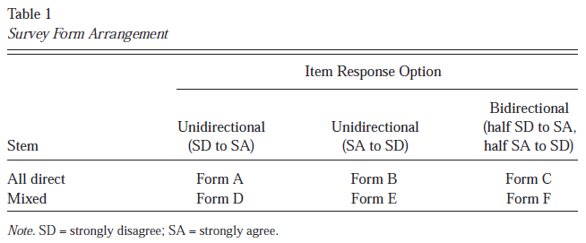

While we’re on the topic of using tables (and figures) from published work, how does one cite such things?

A: In the note of a table or the caption of a figure.

Note the particular form, which is somewhat different than the APA style for references.

The form should be …

In a nod to your homework from a couple weeks ago, let’s look at the data from the Excel file …

Your HW this week: download Myford and Wolfe (2004) from our class homepage and mark the places in the text where the authors refer to the respective tables.