Class #2

February 14, 2013 (Happy Valentine’s Day)

Finish initial table intros (from last week)

Titles:

Tables – title case (important words capitalized), italics; “Table 1”(no italics)

* Tables numbered consecutively

Figures – sentence case (first word, proper nouns capitalized), no italics; “Figure 1” (italics)

Table introductions (students have brought one each)

Very nice list, intro of tables: *http://www.ncsu.edu/labwrite/res/gh/gh-tables.html*

Types of tables:

1. textual table

2. statistical table

3. numerical table

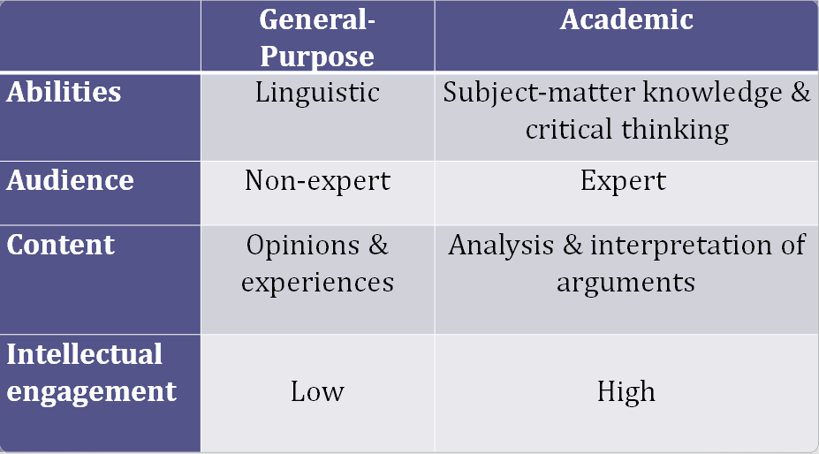

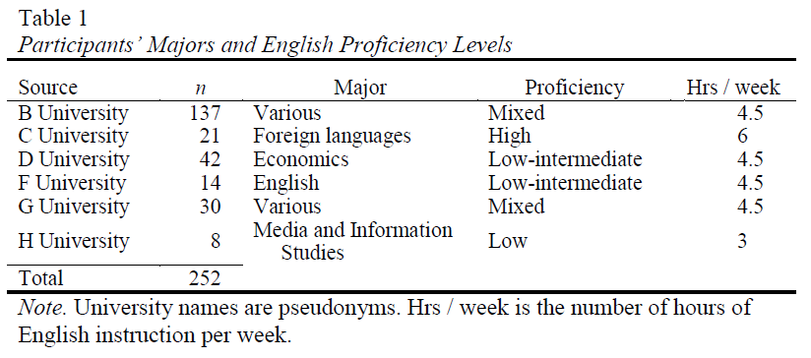

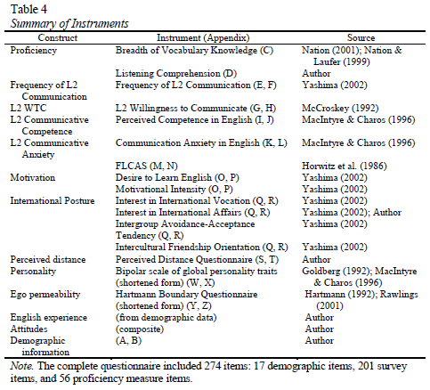

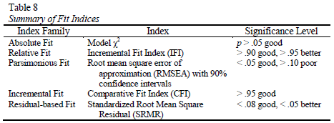

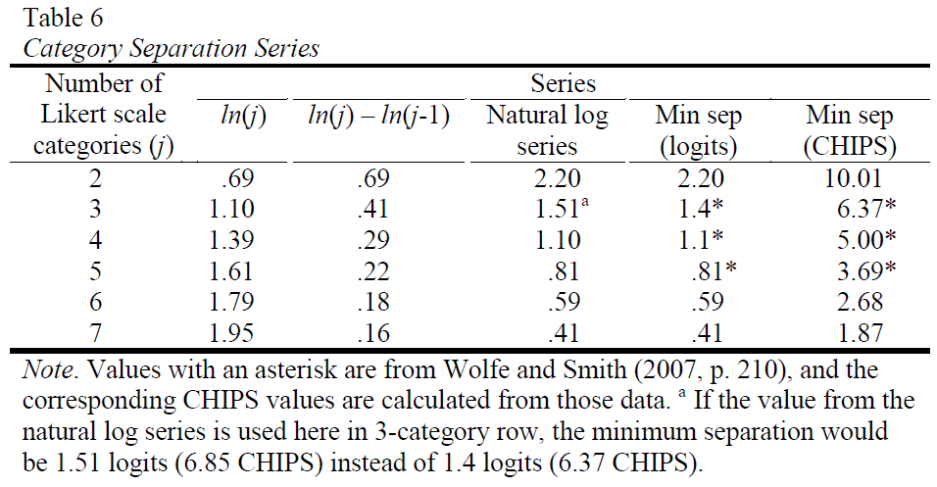

|  |  |  |  |  |
| --- | --- | --- | --- | --- |
| Table 3.*Pattern Matrix for Willingness to Use Technology (Japan 2009 Data)* | | | | |
|  | Components | | |  |
| Task | Synchronous | Asynchronous | Chatting | *h2* |
| *Synchronous Communication* | |  |  | .477 |
| Presentation (PPT) | .676 |  |  | .477 |
| Mail exchange | .638* |  |  | .417 |
| Divide check | .594 |  |  | .327 |
| Contact teacher | .559 |  |  | .322 |
| Get class info | .487 |  |  | .280 |
| *Asynchronous Communication* | |  |  |  |
| Test-taking | (-.256) | .779 |  | .579 |
| Memo |  | .635 |  | .411 |
| Budget |  | .513 |  | .397 |
| 5-page report |  | .499 |  | .330 |
| Reference material |  | .414 |  | .378 |
| Chatting (Internet) |  |  | .871 | .029 |
| Eigenvalue | 2.345 | 1.601 | 1.101 |  |
| % of variance | 21.32% | 14.56% | 10.01% |  |
| *Note.* The secondary loading of ‘test-taking’, although below the cutoff value of .40, is shown to facilitate comparison with structural equation modeling results below. | | | | |

serif font: Cambria, Times New Roman

sans-serif font: Calibri, Arial

decimal tab

Your homework:

1. Make sure you get something for your husband/wife/significant other for Valentine’s Day.
2. Send me an e-mail and I will then send you some data for making a table.
3. If you haven’t already done so, bring (or send me) a table for you to describe.

elwood.jim@gmail.com