Class #5

November 4, 2014

Delivery: Verbal and Non-Verbal

\*See the PPT and PDF on our class webpage.

1. Display notes during presentation

On the Slide Show tab, you’ll see a ‘Monitors’ menu as shown below. Just click that ‘Use Presenter View’ and when you begin your presentation the main screen for your audience will be the left image and you will see the right image.

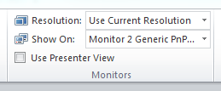

Of course, on the right image you can see the slide, your speaking notes on the right side, and a clock on the bottom edge – very helpful!

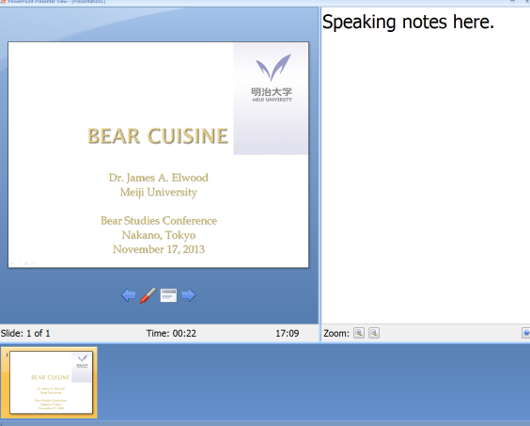

http://office.microsoft.com/en-001/powerpoint-help/view-your-speaker-notes-privately-while-delivering-a-presentation-on-multiple-monitors-HA010067383.aspx