Class #4

October 28, 2014

Happy Halloween!

The nuances, the ins-and-outs of PowerPoint

1. Basic construction
2. Styles
3. Customized styles
4. Adding logos, etc.
5. Slide transitions: my favorites are **fade** and **wipe**
6. Animation: text and to point out things …
7. Insert a shape (Insert menu 🡪 Shape 🡪 rounded rectangle
8. On the shape, right click … and choose “Format shape”
9. Select fill 🡪 click “solid fill” 🡪 adjust transparency … usually about 60%
10. Select line 🡪 click “line color”, “line style” … usually red, about 3.5pt
11. To animate, click on the shape
12. Go to the animation menu and select the style (usually wipe), start (“on click”)  
    duration (usually 1.00 second), and delay
13. ALWAYS check your animation!
14. External links
15. Video, audio files

Font categories 🡨sans serif

Font categories 🡨 serif

*Don’t use Comic Sans!

To change font size …

Control + left bracket [

To make transparent backgrounds …

* Need PNG files (not JPEG)
* 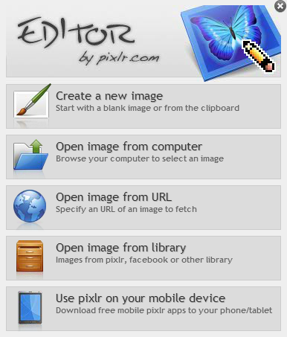Change jpeg to png using pixlr.com

1. Go to pixlr.com
2. Wait …
3. Go to Editor
4. Wait …
5. Click “Launch Web App”
6. On the next screen 🡪
7. Click “Open image from computer”
8. Select your image and click “Open”
9. 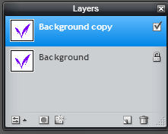Make a duplicate layer: go to the Layer   
   menu and click “duplicate”
10. Open a new image: go to the File menu  
    and select “new image”
11. Drag the image copy onto the new image
12. Grab your Harry Potter Wand Tool …
13. Select (click on) the white background
14. Hit the delete key
15. Save as a PNG file (File menu 🡪 Save)

Your homework: Revise your first powerpoint (yes, I will collect those)

Embed YouTube video into PPT

http://youtu.be/m_dsh18xPhs

Removing white from image background: http://youtu.be/op5ovXHPq_8

Topics to cover:

1. Text boxes – The basic idea is that there are boxes on each slide in which you can enter many things. Of course, one possibility is to enter text, but you can also enter images (photos, screenshots), videos, links, tables, etc.

In this screenshot, you can see two text boxes. The top one is, of course, for the title of your presentation, and the lower one is for a subtitle or simply for text.

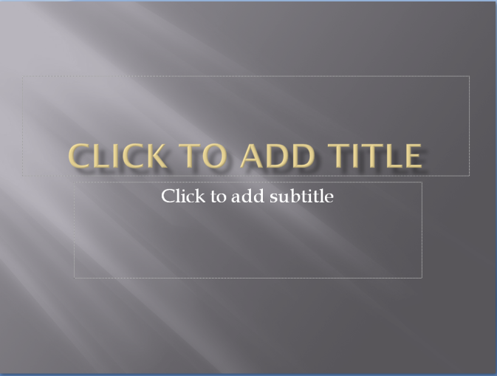

You can select among different slide designs if you click “New Slide” on your Home menu; you can also click on “Layout” just to the right for the same choices.

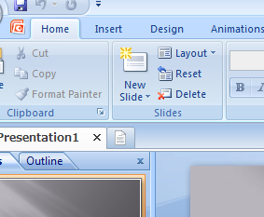

1. Background

To work with the background of your PowerPoint, you’ll need to go to the Design tab. On that tab you’ll see a “Background” section that looks like this:

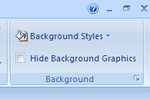

If you click on the “Background Styles” you can choose among several different styles (how clever!), and at the bottom of that dialog box you’ll see a “Format Background” link. When you click that you will get the “Format Background” dialog box, which looks like this.

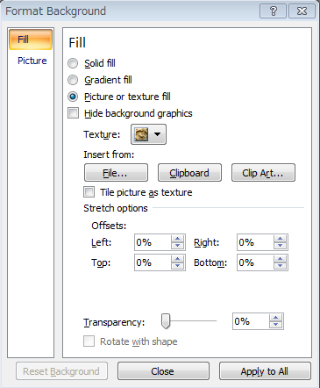

Let’s look at an example, shall we? Suppose that I want to make a presentation that is sponsored by my university, Meiji. Thus, I want to insert the Meiji logo and then modify it how I want; the steps were as follows:

1. Insert a picture from a file,

2. Move it to the right side of the slide (left offset = 75%, so the picture occupies the right 25%),

3. Move it to the top of the slide (bottom offset = 50%, so the picture occupies the upper 50% of the slide),

4. Make the image partially transparent so it doesn’t distract from the content of my presentation (Transparency = 50%).

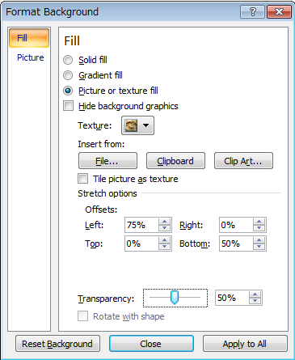

Finally, I click “Apply to All” so that every slide has this background. The background looks like this:



Of course, you can simply add colors, different textures, and the like – I’d suggest just playing a bit and finding something that you like.

1. Font (serif vs. sans-serif, families)

On your computer you probably have 50 or more fonts to choose from, but they basically come in the categories, serif or sans serif. Serif fonts have the little ‘feet’ on letters; an example is Times New Roman. Serif fonts are used in nearly all academic work such as your GRIPS graduation paper (hint, hint). Times New Roman is a widely-used and very elegant font, and I also use Cambria, which I find to be a stronger yet still elegant font. Some other serif fonts are Garamond and Lucida. Allow me to make a **strong** suggestion, everyone: never, ever, ever use Century! I find Century to be weak, and the placement of punctuation is terrible; thus, please do not use it. (Note that many English computer use Century as the default font, so be careful.

The other category of font is sans serif, which simply means “without serif”. The font you’re reading right now is Calibri, which I use for my classroom notes. Other examples are Arial and Candara. The reason I use them in my classroom is that on a screen the letters are fatter and therefore easier to see.

The choice of which to use is up to you, but please consider your speaking venue. For example, if the venue is, for example, a large room, you might do better with a sans serif font. However, for a small room in which everyone is reasonably close to the screen (imagine our classroom), then a serif font should be fine.

One further note about font: Always check that the color is easy to see against your background. The font should contrast strongly enough that it is easy to see.

1. Display notes during presentation

On the Slide Show tab, you’ll see a ‘Monitors’ menu as shown below. Just click that ‘Use Presenter View’ and when you begin your presentation the main screen for your audience will be the left image and you will see the right image.

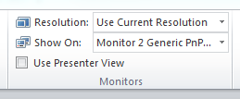

Of course, on the right image you can see the slide, your speaking notes on the right side, and a clock on the bottom edge – very helpful!

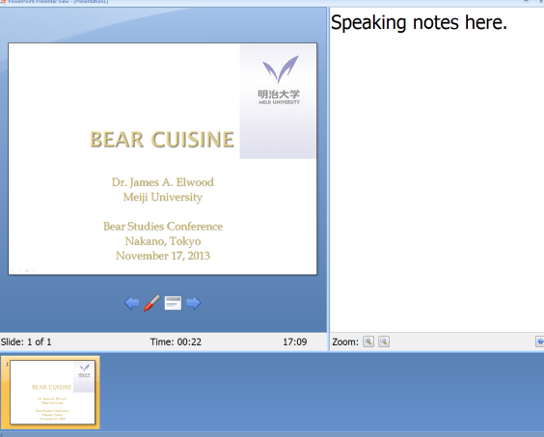

http://office.microsoft.com/en-001/powerpoint-help/view-your-speaker-notes-privately-while-delivering-a-presentation-on-multiple-monitors-HA010067383.aspx