Growth of Ethanol Fuel Stalls in Brazil

The nation's shortages are a sobering lesson for a biofuels pioneer

By Claudio Angelo and *Nature* magazine

Brazil has struggled to sustain its production of biofuel from sugar cane.

“A new moment for mankind.” That was how Brazil’s former president, Luiz Inácio Lula da Silva, described his

country’s biofuel boom in March 2007. Back then, Brazil was the poster child of ethanol fuel, its output second only to that of the United States. Fermenting the sugars in the country’s abundant sugar cane produced a motor fuel that lowered carbon dioxide emissions, and many saw Brazil as a model for how the world could shed its addiction to oil, creating jobs along the way.

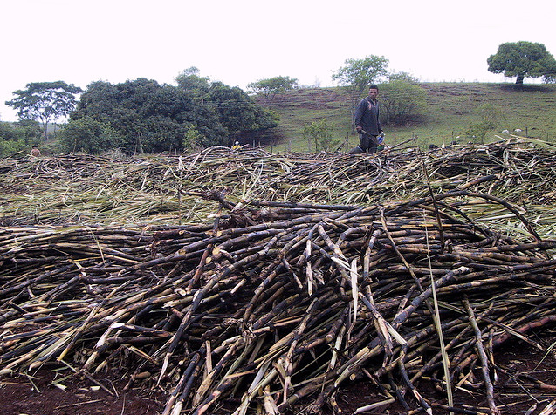Five years on, Lula’s vision has tarnished. Biofuels are falling from grace around the world as critics charge that devoting millions of hectares of agricultural land to fuel crops is driving up food prices and that the climate benefits of biofuels are modest at best. But the fall has been hardest in Brazil, where government policies have compounded the effects of the global economic downturn.

Domestic consumption of liquid ethanol this year has been 26% lower than for the same period in 2008. Forty-one of the country’s roughly 400 sugar-cane ethanol plants have closed over that time. The price of pure ethanol at the pump is so high that in most states it is cheaper to fill up flexible-fuel cars with petrol blends that contain about 20% ethanol. The shift back to fossil fuels, combined with rapid growth in the number of cars on the roads (see ‘Fuelling Brazil’s transport boom’), has worsened city smog and caused emissions in the transport sector to spike at about 170 million tons of CO2 in 2011, up from less than 140 million tons in 2008. “We are increasing the world’s GDP: we are buying more oil and spending more on pollution-related health care,” jokes Ildo Sauer, who studies energy policy at the University of São Paulo and is a former director of the state oil giant Petrobras.

Brazil’s ethanol roller coaster is a sobering example of what can happen when climate and energy planning clash with economic decision-making. It began with the 2008 economic crisis, which staunched new investments in the sector just as it was expanding rapidly, and deep in debt. Rather than developing new plantations, the industry fell back on harvesting cane from older, less-productive sites, and average yields plummeted from 115 tons per hectare in 2008 to 69 tons this year. Combined with two bad harvests, this has forced Brazil to import some 1.5 billion liters of maize (corn) ethanol from the United States over the past 2 years.

But the killer blow came when the government decided to freeze the price of petrol and diesel to keep inflation under control, leaving biofuels less competitive. On the very night that current President Dilma Rousseff gave the closing speech of the Rio +20 conference in June — the final agreement of which promised to phase out fossil-fuel subsidies — the government said it would be reducing a federal fuel tax to zero. “We have taken away jobs from agroindustry, stalled growth and worsened the air of our cities for the sake of inflation control,” says Luiz Horta, a bioenergy researcher at the Federal University of Itajubá.

Meanwhile, the government has tried to stimulate the economy with tax breaks on the sale of new cars. That, combined with the cost of pure ethanol, has meant that “the share of alcohol in our transport fuel matrix has dropped from 55% in 2008 to 35%”, says André Ferreira, head of the Institute for Energy and the Environment, a think-tank in São Paulo.

According to Antônio de Pádua Rodrigues, technical director and acting president of UNICA, Brazil’s sugar-cane industry association, the government knows that the situation is unsustainable. It has promised the industry that petrol prices will go up next year, and that the blend of ethanol will rise from 20% to 25%, the maximum allowed by law. But it will take time for the industry to bounce back from its poor fortune, and ethanol is likely to remain scarce and expensive for the next two years, say Rodrigues and Horta.

Now, Brazil hopes to tap into a new biofuel source: second-generation ethanol, produced from the tough cellulose in plant stalks. Cellulose is difficult to break down and ferment, but several facilities in the United States are on the verge of making commercial cellulosic ethanol — for example, by using specialist enzymes to break down the long-chain cellulose molecules — and Brazil doesn’t want to be left behind.

In December last year, the Brazilian Development Bank launched a 1-billion-real (US$481-million) credit line to stimulate research and development in cellulosic biofuels and other advanced sugar-cane technologies. The Center for Sugarcane Technology, an industry-sponsored organization based in São Paulo, has taken up a 357-million-real loan to build a cellulosic ethanol plant next year, which would use waste plant matter from conventional sugar-cane fermentation. “We can double fuel yield per hectare when the technology is mature,” says Oswaldo Godoy, a project manager at the organization.

The Brazilian Agricultural Research Company (EMBRAPA) is also throwing its weight behind bioenergy. Its president, Maurício Lopes, a geneticist who took office in October, has promised to build up research on biomass technology and double EMBRAPA’s funding for that area, which today stands at a modest 24 million real per year. “I want to believe that the current state of the ethanol sector is a temporary blip,” he says. Lopes says that Brazil will be “unbeatable” once cellulosic technology matures. “No other country has the logistics we have in place, or the number of different species we can derive ethanol from.”

But cellulosic ethanol won’t be a quick fix, says Horta. “Nothing shall compete with conventional sugar-cane ethanol until 2050.”

*This article is reproduced with permission from the magazine Nature. The article was first published on November 27, 2012.*