Class #2 (April 21, 2015)

Glass half full

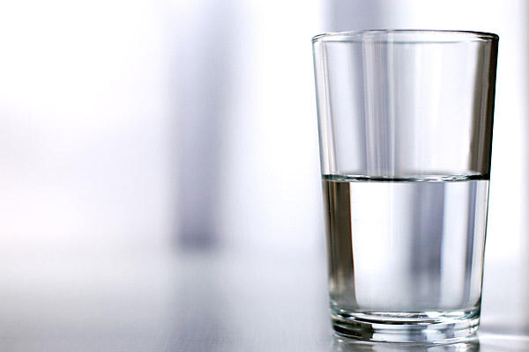

*Discussion of email collection (homework from last week).*

Best,

Dr. E

Mr. Tanaka

Miss Suzuki

Mrs. de Nivi 🡪 Clarene (JE: Mrs. de Nivi was my 6th-grade teacher.)

Mr. Burrows

Best regards,

JE

g

Best,

McJim

identity

concise

Please contact me if you have any questions.

* Should any questions arise, please feel free to contact me at your convenience.

I would like you to check my homework.

May I ask you to …, please?

I would appreciate you

Thank you for your cooperation.

I look forward to your cooperation. 🡪 sounds like a policeman talking to a suspect …

*Imagine a parent speaking to a child …

Would you like to clean your room now?

**Tip: Avoid mentioning deadlines …**

May I ask you to read my paper and provide feedback by May 4th?

May I ask you to read my paper and provide feedback as soon as possible?

(first message) May I ask you to read my paper and provide feedback?

(reply) Yes, of course.

(second message) Thank you very much. When might I receive your comments?

Homework:

On our class webpage, I will post abstracts for 4-5 articles about politeness in   
email(s). Please read the abstracts and then ask me to send you one article.