GRIPS Catalogue

1. Go to GRIPS library (<http://www.grips.ac.jp/main/lib/index.html> or Google GRIPS Library).
2. Click on Online Catalogue.

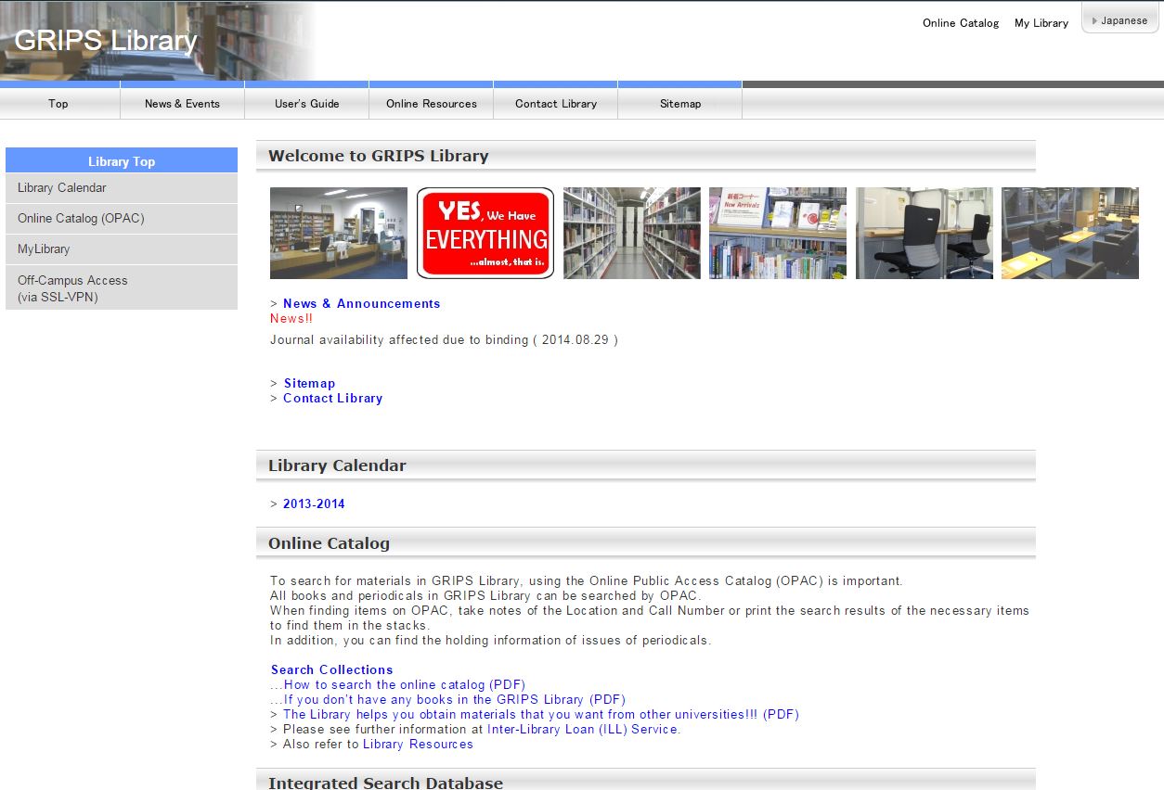

1. Log in (Top right-hand corner).
2. Search the catalogue.

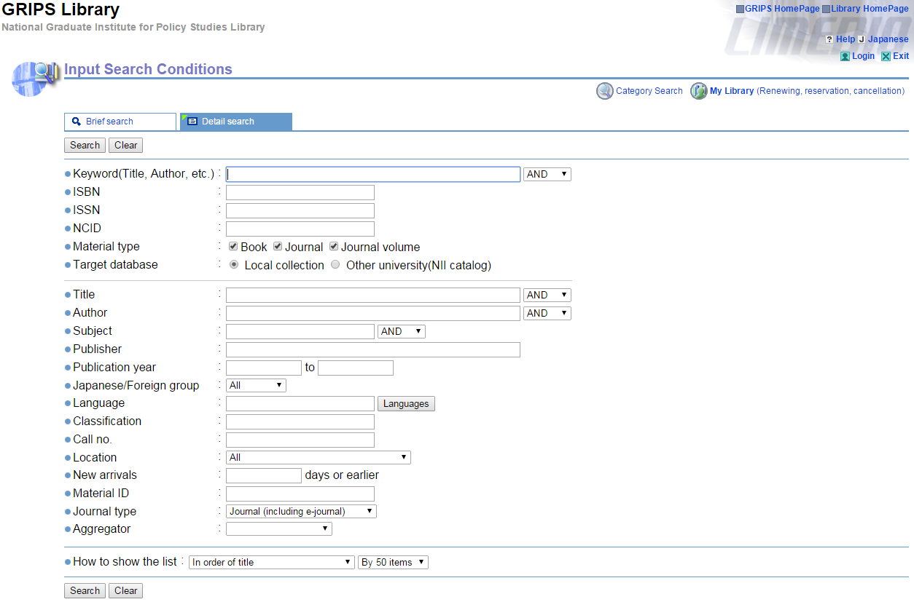

1. Choose a publication.

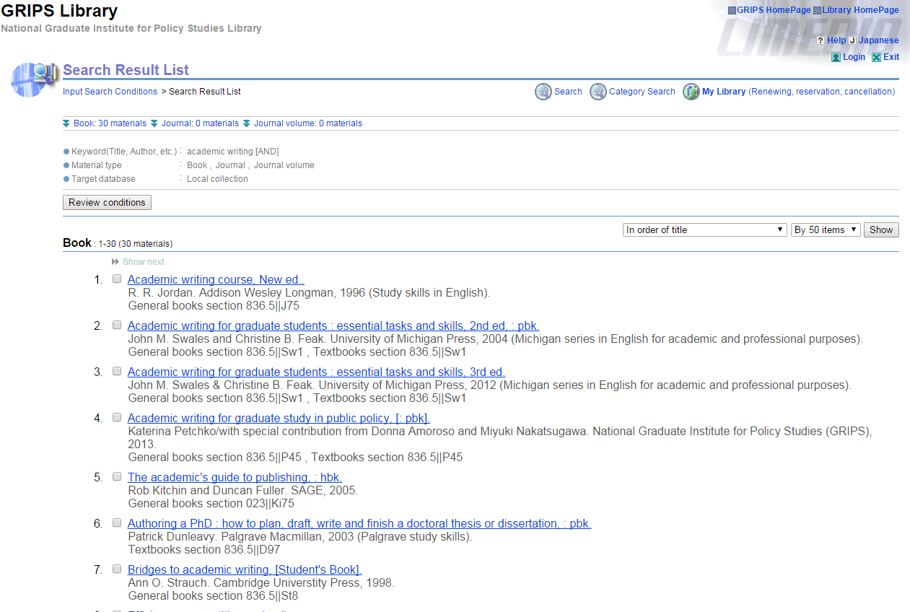

1. Bookmark a publication.

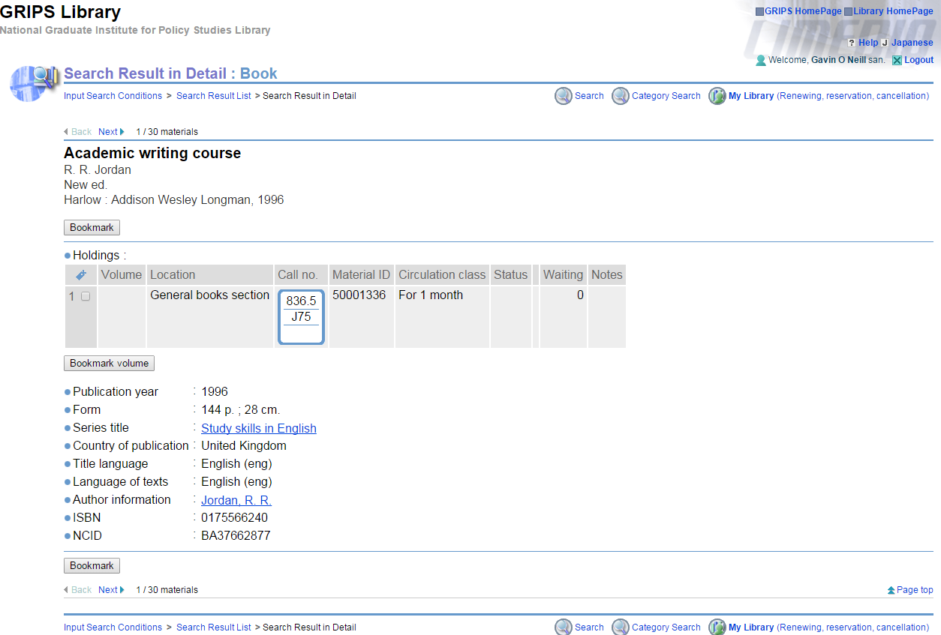

1. Go to the library!

EBSCO

1. Go to GRIPS library (<http://www.grips.ac.jp/main/lib/index.html> or Google GRIPS Library).
2. Click on Online Resources/Online Databases.

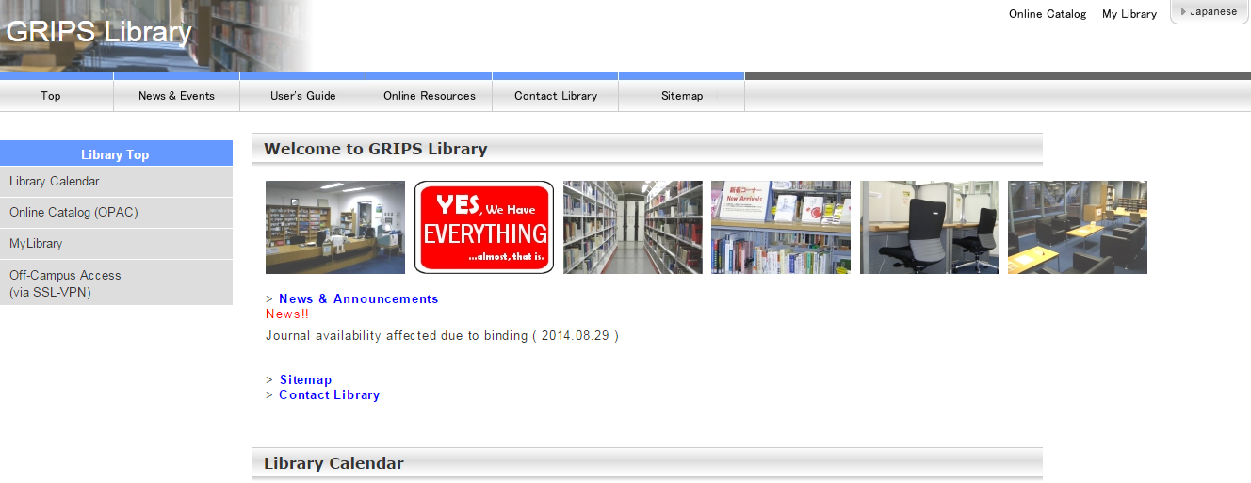

1. Click on EBSCOhost Integrated Search (EHIS).

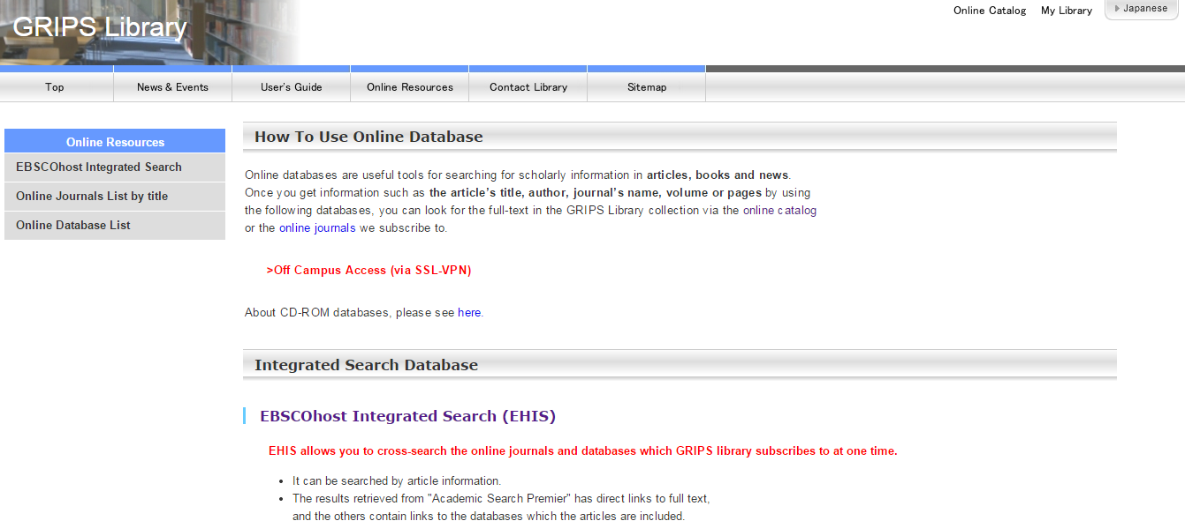

1. Click on Sign In.

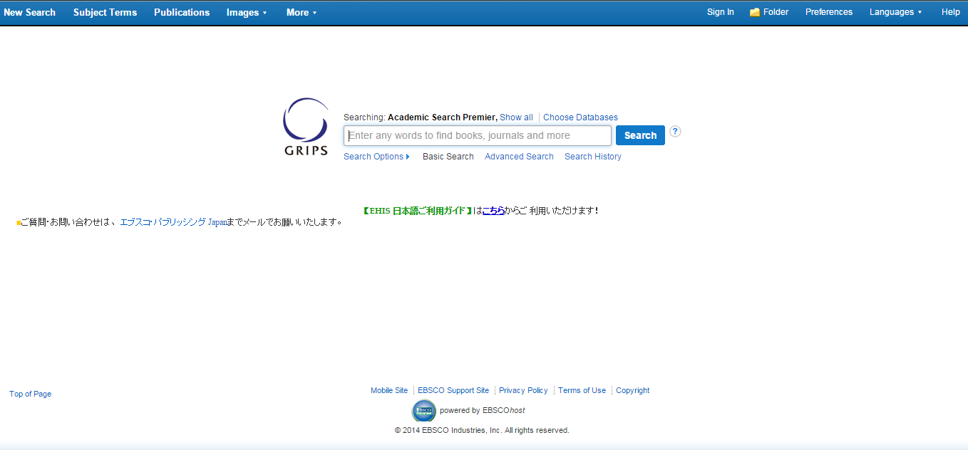

1. Click on Create a New Account.

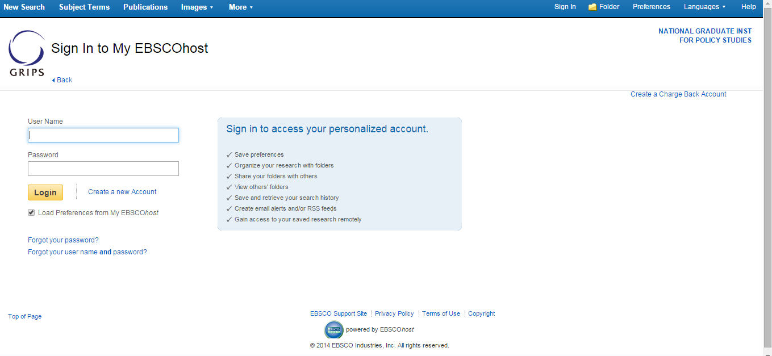

1. Fill in the form and click on Save Changes.

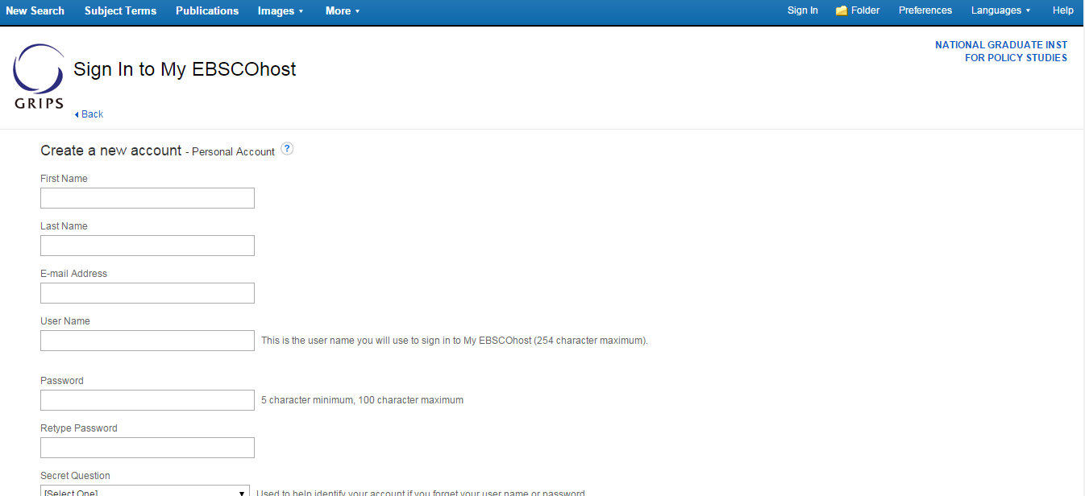

1. Click on New Search.

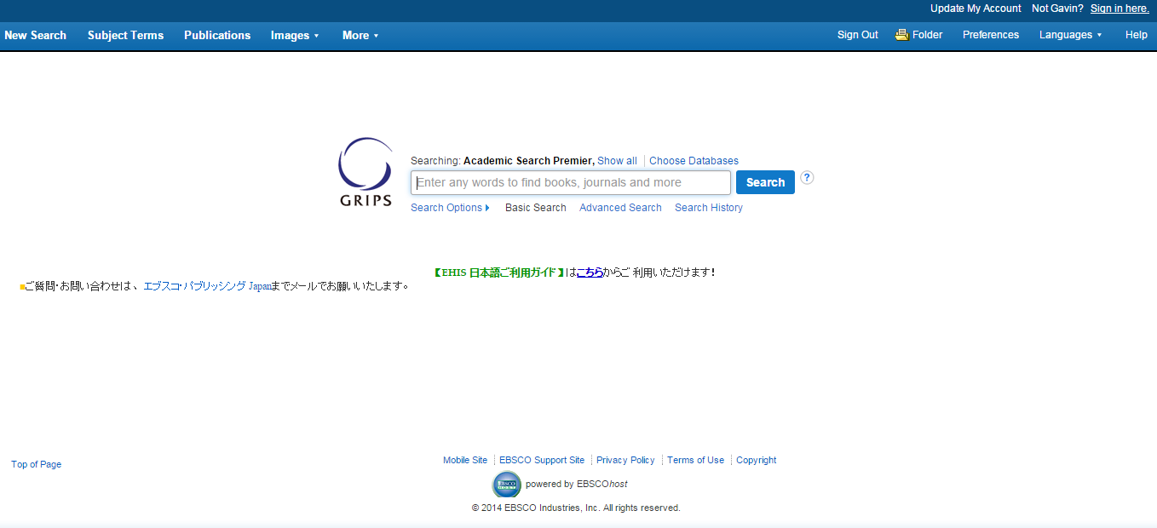

1. Click on Advanced Search. You can use Boolean search operators and other search limiters.

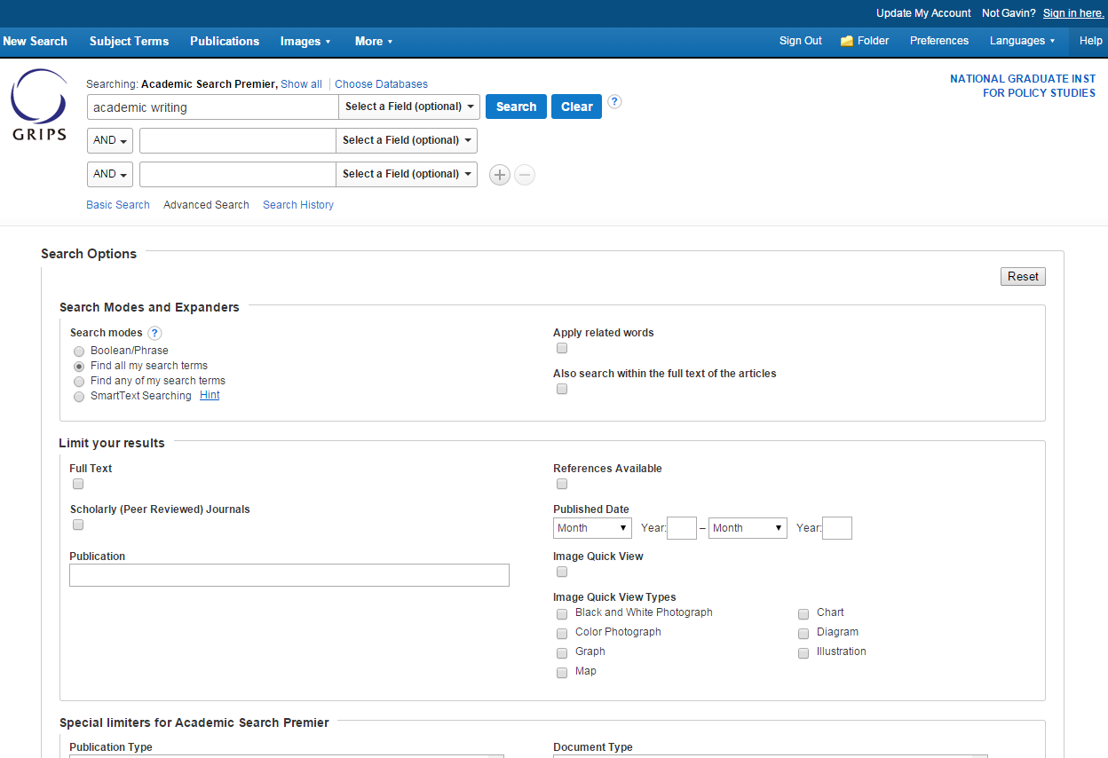

1. Make search selections (full text & publication date).
2. Click Search.
3. Further refine search, click on a publication, or download a PDF.

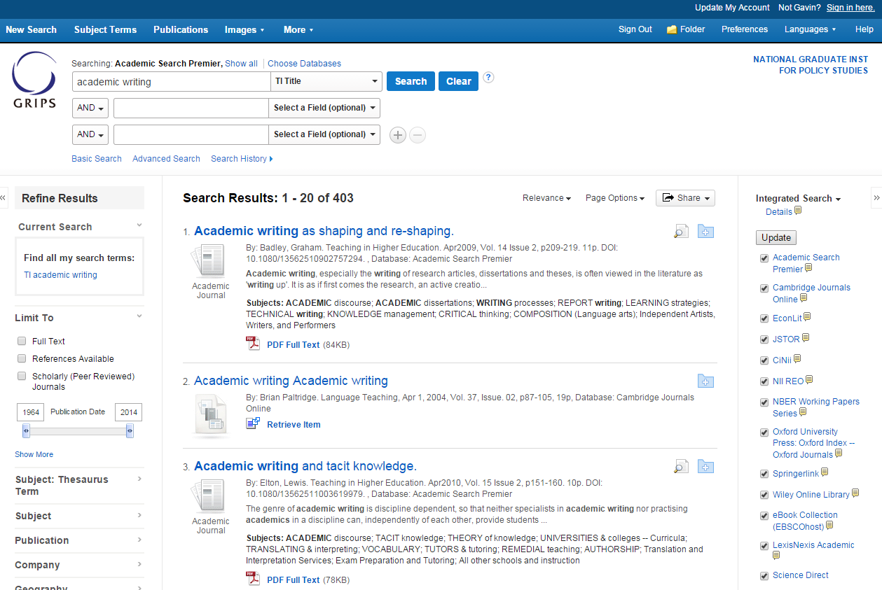

1. Choose from the options on the left or right. Recommended – Add to Folder, E-mail, Save, Cite, Create Note, Keyword Search, and PDF Full Text.

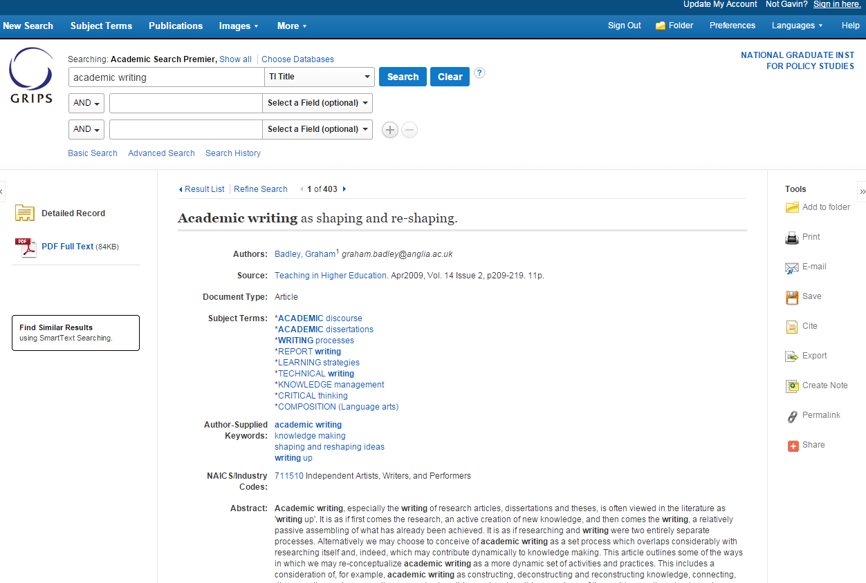

* Add to Folder: This will save your selection to your own personal folder so that the next time you log in you can access the results of your searches.
* Email: This will email whatever is on the page to your email address. This could be bibliographical information, the PDF, or the APA citation.
* Save: This will allow you to save all or a part of a document. This feature is very useful when your source is an e-book. You cannot download the entire e-book, but this may allow you to download a chapter in the book.
* Cite: This will provide the reference citation for the material, which you can copy and paste into your references. The citation will sometimes need editing, especially the capitalization of titles.
* Create Note: This will allow you to make notes on a PDF document (e.g., summary or main points of interest) and you can then save the document to your folder.
* Keywords: This will let you search for other sources on your topic using related terms.
* PDF Full Text: This will allow you to download the PDF of the text. This feature is not always available.

Google Scholar

[http://scholar.google.co.jp](http://scholar.google.co.jp/)

* fill in the blank operator

e.g., there are * countries in the world

.. range

e.g., sub-Saharan migration 2000..2013

filetype: specify type of file

e.g., sub-Saharan migration 2000..2010 filetype: PDF

- remove unwanted results

e.g., sub-Saharan migration 2000..2010 filetype: PDF –hiv

“ “ exact words only

e.g., "illegal border crossings in Ceuta and Melilla are just the tip of an iceberg"

site: search a site

e.g., site: WHO.int gm crops

~ related terms

e.g., ~ODA

OR synonyms or alternative forms

e.g., oda OR "foreign aid" in sub-Saharan Africa

intitle: only words in title

e.g., intitle: oda OR "foreign aid" in sub-Saharan Africa

Please visit: <http://www.googleguide.com/advanced_operators_reference.html>

Treasure Hunt

Complete the following activities.

EBSCO

* Find a full-text PDF article on the topic of foreign aid in Cambodia. Copy the APA citation and save the search result to your folder.
* Conduct the following advanced search: *Foreign Direct Investment in India AND FDI*. Limit the results by selecting *Full Text*. Remove all databases except e-books. If *Research Handbook on International Financial Regulation* is available, find the chapter on the regulation of FDI. First, *Save* the chapter (section) and then email this to your GRIPS email account with an APA citation.

Goggle Scholar

* Search Google scholar for sources published within the last 10 years on the topic of FTAs (and related terms) in Asia that do not mention ASEAN in the title. The source should be available in PDF. List the top three results.

GRIPS Library

* You have heard that an author named Earl Babbie is well known for his work in the social sciences. Check if the library has any of his books. If so, get the Call no.

All/Any Method

* Find three ACADEMIC sources on the topic that you have chosen for your research project. Save the information or full text in your preferred manner.