Obama Forecasts Economic Opportunity in Fighting Global Warming

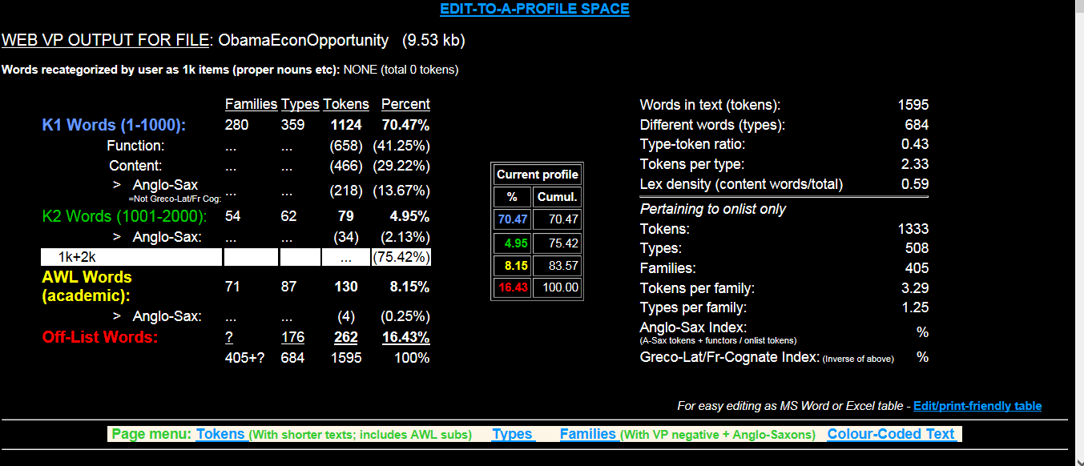

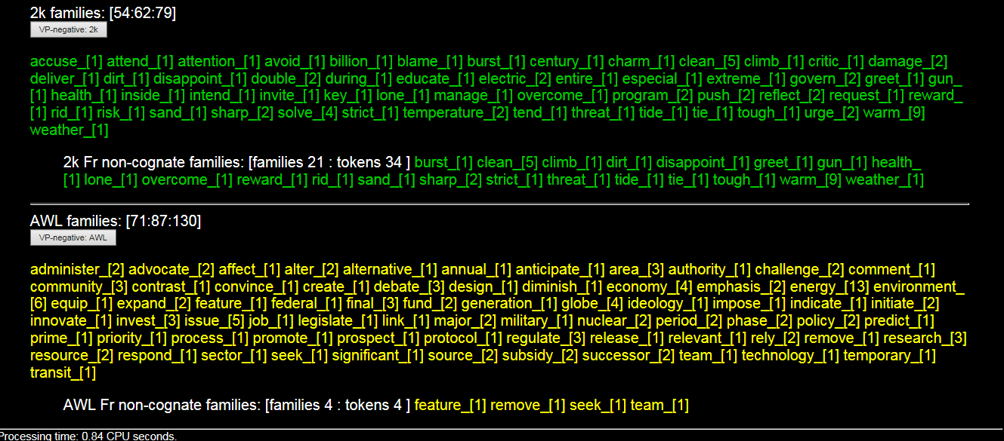

AWL families: administer_[2] advocate_[2] affect_[1] alter_[2] alternative_[1] annual_[1] anticipate_[1] area_[3] authority_[1] challenge_[2] comment_[1] community_[3] contrast_[1] convince_[1] create_[1] debate_[3] design_[1] diminish_[1] economy_[4] emphasis_[2] energy_[13] environment_[6] equip_[1] expand_[2] feature_[1] federal_[1] final_[3] fund_[2] generation_[1] globe_[4] ideology_[1] impose_[1] indicate_[1] initiate_[2] innovate_[1] invest_[3] issue_[5] job_[1] legislate_[1] link_[1] major_[2] military_[1] nuclear_[2] period_[2] phase_[2] policy_[2] predict_[1] prime_[1] priority_[1] process_[1] promote_[1] prospect_[1] protocol_[1] regulate_[3] release_[1] relevant_[1] rely_[2] remove_[1] research_[3] resource_[2] respond_[1] sector_[1] seek_[1] significant_[1] source_[2] subsidy_[2] successor_[2] team_[1] technology_[1] temporary_[1] transit_[1]

