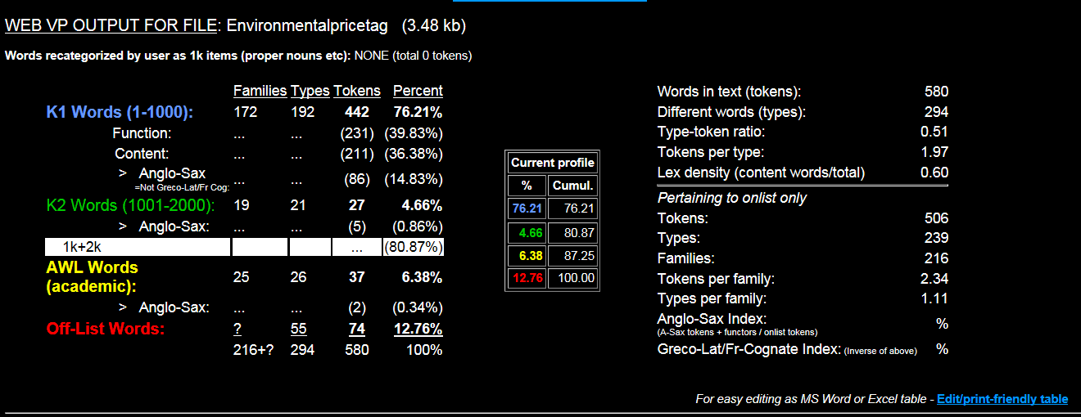

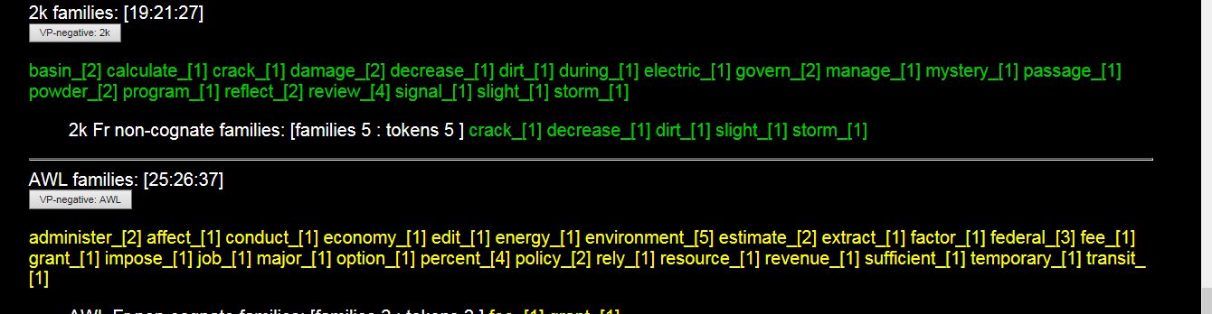
AWL families: administer_[2] affect_[1] conduct_[1] economy_[1] edit_[1] energy_[1] environment_[5] estimate_[2] extract_[1] factor_[1] federal_[3] fee_[1] grant_[1] impose_[1] job_[1] major_[1] option_[1] percent_[4] policy_[2] rely_[1] resource_[1] revenue_[1] sufficient_[1] temporary_[1] transit_[1]

