Gigalopolises Revised

Lexical Profile

*Note: The pink words (“User List”) are intentionally excluded; most are place names or personal names.*

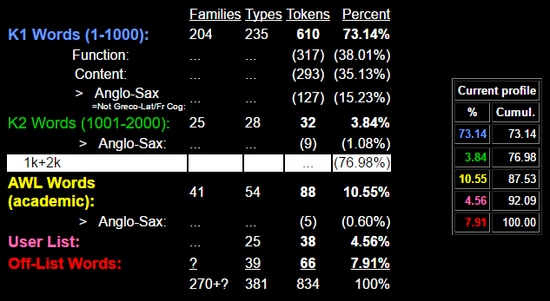

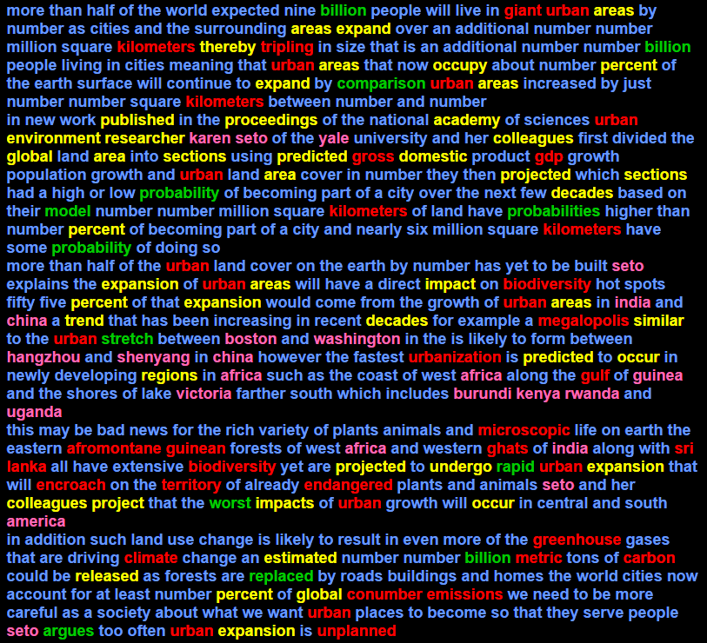

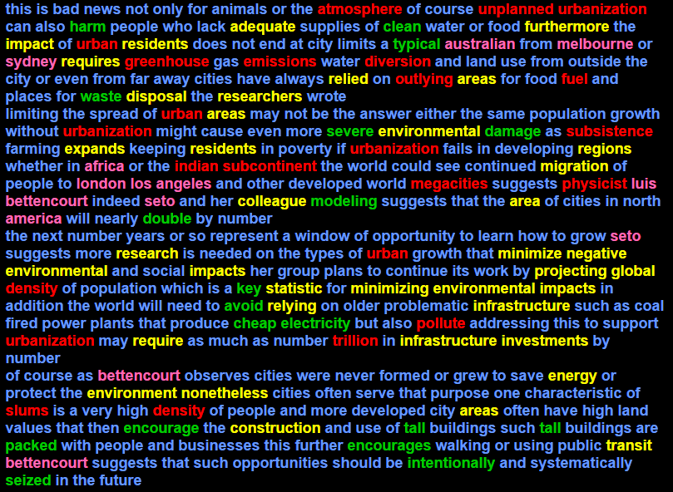

1001-2000: argues avoid billion billion billion cheap clean comparison damage double electricity encourage encourages harm intentionally key model modeling packed probabilities probability probability rapid replaced seized severe stretch tall tall typical waste worst

AWL: academy adequate area area area areas areas areas areas areas areas areas areas areas colleague colleagues colleagues construction decades decades disposal domestic energy environment environment environmental environmental environmental estimated expand expand expands expansion expansion expansion expansion furthermore global global global impact impact impacts impacts impacts infrastructure infrastructure investments migration minimize minimizing negative nonetheless occupy occur occur percent percent percent percent predicted predicted proceedings project projected projected projecting published regions regions released relied relying require requires research researcher researchers residents residents sections sections similar statistic thereby transit trend undergo

Sublist 1: area area area areas areas areas areas areas areas areas areas areas environment environment environmental environmental environmental estimated occur occur percent percent percent percent proceedings require requires research researcher researchers sections sections similar

Sublist 2: construction impact impact impacts impacts impacts investments regions regions residents residents

Sublist 3: negative published relied relying

Sublist 4: adequate domestic occupy predicted predicted project projected projected projecting statistic

Sublist 5: academy energy expand expand expands expansion expansion expansion expansion transit trend

Sublist 6: furthermore migration

Sublist 7: decades decades disposal global global global released

Sublist 8: infrastructure infrastructure minimize minimizing thereby

Sublist 10: colleague colleagues colleagues nonetheless undergo

TECHNICAL LIST: africa africa africa africa america america angeles australian bettencourt bettencourt bettencourt boston burundi china china guinea hangzhou india india karen kenya london los luis melbourne rwanda seto seto seto seto seto seto shenyang sydney uganda victoria washington yale

OFF LIST: afromontane atmosphere biodiversity biodiversity carbon climate conumber density density diversion emissions emissions encroach endangered fuel gdp ghats giant greenhouse greenhouse gross guinean gulf indian kilometers kilometers kilometers kilometers lanka megacities megalopolis metric microscopic outlying physicist pollute slums sri subcontinent subsistence territory trillion tripling unplanned unplanned urban urban urban urban urban urban urban urban urban urban urban urban urban urban urban urban urbanization urbanization urbanization urbanization urbanization