Gigalopolises Original

Lexical Profile

*Note: The pink words (“User List”) are intentionally excluded; most are place names or personal names.*

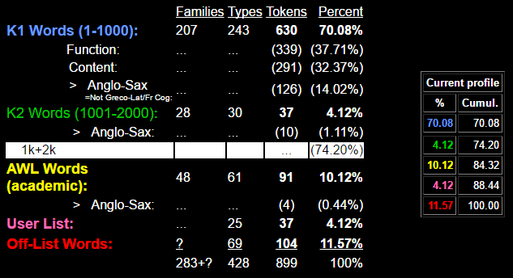

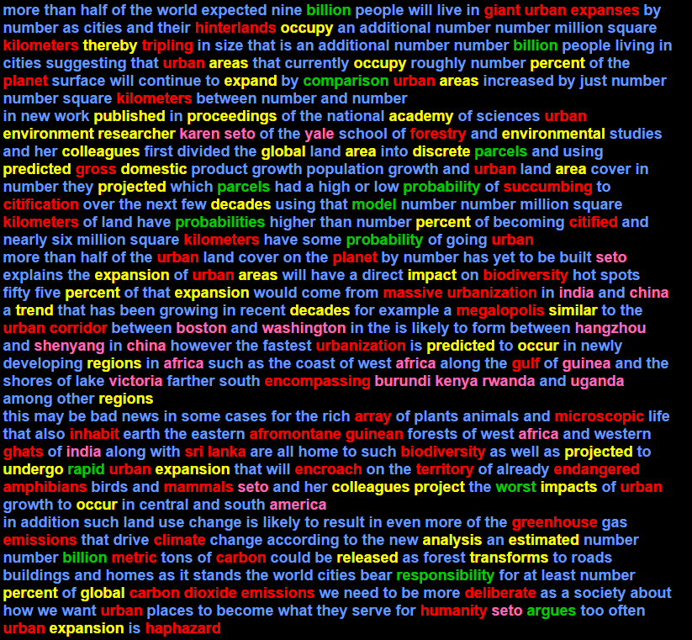

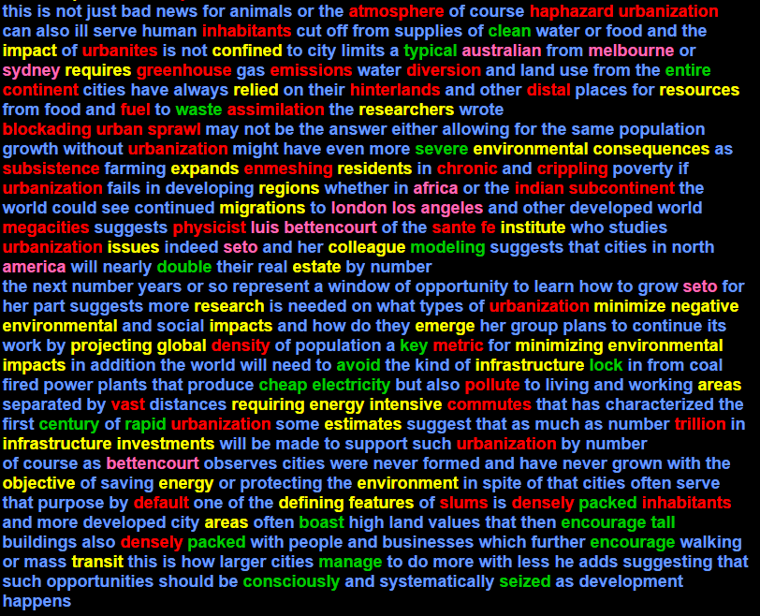

1001-2000: argues avoid billion billion billion boast century cheap clean comparison consciously double electricity encourage encourage entire key lock manage model modeling packed packed parcels parcels probabilities probability probability rapid rapid responsibility seized severe tall typical waste worst

AWL: academy analysis area area areas areas areas areas areas colleague colleagues colleagues confined consequences decades decades defining discrete domestic emerge energy energy environment environment environmental environmental environmental environmental estate estimated estimates expand expands expansion expansion expansion expansion features global global global impact impact impacts impacts impacts infrastructure infrastructure institute intensive investments issues migrations minimize minimizing negative objective occupy occupy occur occur percent percent percent percent predicted predicted proceedings project projected projected projecting published regions regions regions released relied requires requiring research researcher researchers residents resources similar thereby transforms transit trend undergo

Sublist 1: analysis area area areas areas areas areas areas defining environment environment environmental environmental environmental environmental estimated estimates issues occur occur percent percent percent percent proceedings requires requiring research researcher researchers similar

Sublist 2: consequences features impact impact impacts impacts impacts institute investments regions regions regions residents resources

Sublist 3: negative published relied

Sublist 4: domestic emerge occupy occupy predicted predicted project projected projected projecting

Sublist 5: academy discrete energy energy expand expands expansion expansion expansion expansion objective transit trend

Sublist 6: estate migrations transforms

Sublist 7: decades decades global global global released

Sublist 8: infrastructure infrastructure intensive minimize minimizing thereby

Sublist 9: confined

Sublist 10: colleague colleagues colleagues undergo

TECHNICAL LIST: africa africa africa africa america america angeles australian bettencourt bettencourt boston burundi china china guinea hangzhou india india karen kenya london los luis melbourne rwanda seto seto seto seto seto seto shenyang sydney uganda victoria washington yale

OFF LIST: afromontane amphibians array assimilation atmosphere biodiversity biodiversity blockading carbon carbon chronic citification citified climate commutes continent corridor crippling default deliberate densely densely density dioxide distal diversion emissions emissions emissions encompassing encroach endangered enmeshing expanses fe forestry fuel ghats giant greenhouse greenhouse gross guinean gulf haphazard haphazard hinterlands hinterlands humanity indian inhabit inhabitants inhabitants kilometers kilometers kilometers kilometers lanka mammals massive megacities megalopolis metric metric microscopic physicist planet planet pollute sante slums sprawl sri subcontinent subsistence succumbing territory trillion tripling urban urban urban urban urban urban urban urban urban urban urban urban urban urban urbanites urbanization urbanization urbanization urbanization urbanization urbanization urbanization urbanization urbanization vast