E-BRIDGE TO MOBILITY: A NON-FORMAL ONLINE LEARNING EUROPEAN PLATFORM

EXECUTIVE SUMMARY

E-bridge to mobility is a platform designed to encourage a more prospective future for people from Poland, Slovakia, Bulgaria and Romania. The objective of this project is to promote mobility to the UK, Germany and Spain, by offering: education, via English, German and Spanish language courses; practical information about the UK, Germany and Spain; membership in e-community. The project is addressed to people who seek employment in England, Germany and Spain.
Its most important goal is learning English, German and Spanish, and gaining knowledge about the country that the project participant intends to visit. The products and information regarding country-specific characteristics of England, Germany and Spain are complementary to the course. E-bridge supports adjustment to the requirements of the European job market, and its users have the opportunity to learn a foreign language with the aid of innovative communication tools, such as the internet and mobile phones.

organization background

Project title: E-bridge to mobility.

Originator and coordinator of the project: Warsaw Academy of Computer Science, Management and Administration.

Transnational European Project Partners:
- Technical University of Gabrovo (Bulgaria)
- WBS Training AG (Germany).
- Iturbrok S.L. (Spain).
- Soros Educational Center Foundation (Romania).
- Technical University of Kosice (Slovakia).
- Entente UK (United Kingdom).
- Mescomp Technologies SA (Poland).

Funding: Lifelong Learning Programme (Transversal program; Key Activity 3: ICT) coordinated by the Education, Audiovisual and Culture Executive Agency (EACEA) in
Brussels.

Project lifetime: 01.01.2009 – 30.04.2011.

The background and the idea of the project: www.2mobility.eu
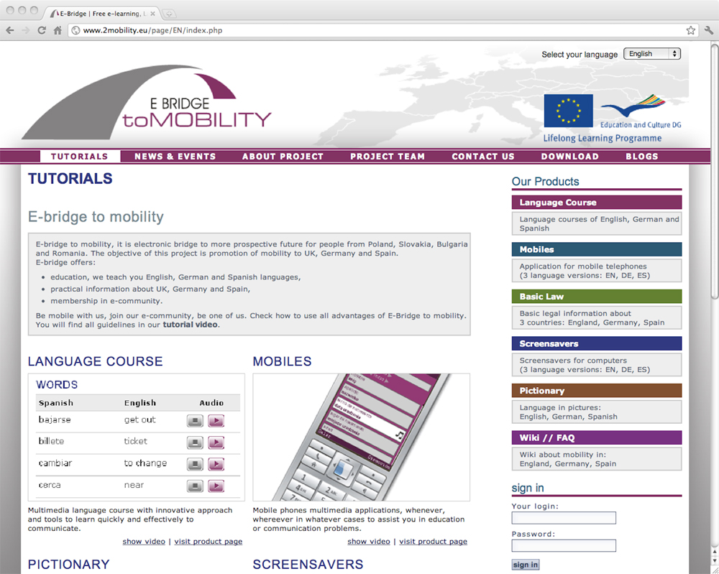

Figure 1.- E-bridge to mobility home page screen shot

SETTING THE STAGE

At the outset red tape discourages job seekers in the EU from considering occupational mobility. For this reason the European Commission has encouraged all EU member states to amend their administrative regulations, requiring standardization of issues related to social insurance and pension rights.

According to 2009 data, it seems that the unemployment rate in Europe is as high as 8.5%, even higher in some EU countries.

An increasing number of Europeans are seeking professional development opportunities in many countries across the continent. Every EU citizen has the right to occupational mobility under EU mobility legislation. Exploring the specific nature of other cultures, learning foreign languages and gaining valuable experience result in an increased openness to job offers and opportunities.

Raising educational standards, facilitating adaptation to new working conditions and the ability to retrain are important, if not the most important, factors in strengthening the economy in times of crisis.

Some introductory statistics are shown to introduce the necessity of the platform:

- 8.2% of the EU work force has changed jobs after one year. Workers in the EU stay in the same job for an average of 10.6 years, compared to 6.7 years in the US (European Commission, 2004).
- 37% of EU citizens would be ready to move to another EU country to and a job if they were unemployed (European Commission, 2006).
- Approximately 1.5% of the EU’s working age population (EU-25) lives and works in a different Member State from their country of origin (European Commission, 2004).
- 46% of EU citizens believe that long-distance mobility is good for individuals (European Commission, 2006).
- 5% of EU citizens have moved to another EU country at least once (European Commission, 2006).
- Since EU enlargement in 2004, data on labour force from Central and Eastern Europe show that workers coming from the new Member States (EU-10) represent less than 1% of the working age population in all countries except Austria and Ireland (European Commission, 2006a).
- According to a Eurobarometer survey on geographic and labour market mobility held in 2004, when asked what the EU represents for them, 53% of the respondents cited ‘freedom to travel and work in the EU’. The answer came well ahead of the Euro (44%) and peace (36%) (European Commission, 2006).

CASE DESCRIPTION

Realization of the E-Bridge to mobility project addresses the needs that appeared on the EU's labour market after accession of new Member States in 2004 and 2007. The project is a response to a phenomenon of mobility among vocationally active citizens.

A basic didactic objective of the project was to create tools enabling learning three foreign languages and facilitating the process of adjustment to reality of everyday life in Spain, Germany and the United Kingdoms, youth (aged under 25) and elderly people (aged over 50), who plan to move to another E-bridge to mobility is supposed to assist potential beneficiaries in adjustment to the European labour markets, thus increasing the chances of achieving their personal and professional goals. Apart from the acquisition of practical language skills, the users will have an opportunity to become familiar with social, legal and cultural specifics of target countries.

The E-bridge project is meant to develop solutions that would provide examples of good practices in the field of modern didactics. Therefore, these solutions should:

1. Engage learners in the process of learning.
2. Encourage looking for informal and non-formal learning methods.
3. Develop knowledge and skills of learners.
4. Motivate continuous learning.

It was assumed that the main product would be a language course. However, a language course is not enough. For those who change their place of living, everyday situations, such as completing basic application forms, adjusting to everyday circumstances, understanding cultural specifics or becoming familiar with basic legal aspects, which are important from the point of view of an immigrant, can be problematic. It was therefore decided to complete the portal with basic documents, which are important for people changing their country of residence, such as insurance or registration forms. This makes it possible to become familiar with templates of documents and prepare necessary data and documents, as well as to learn useful vocabulary at home, before visiting an office.

The products of the project are: online course of a language and everyday life in the United Kingdom, Germany and Spain (“Language course”), didactic materials available through mobile phones (“Mobiles”), educational screensavers (“Screensavers”), a multimedia glossary (“Pictionary”), a section providing basic legal information (“Basic Law”) and WEB 2.0 tools, enabling blog posting, adding comments, evaluation of didactic materials, etc.

The main assumption of the project is to provide vocabulary, lessons and information available online and downloadable not only to a mobile phone, but also to a computer, accessible using different information and communications technologies (ICTs).

The final product consists of applications facilitating the learning process with the support of information and communication technologies:

1. Desktop and portable computers,
2. The Internet,
3. Wireless and mobile devices, including mobile phones,
4. Different means of electronic communication,
5. WEB 2.0 tools.

The language course is closely connected with all the other products, which have a complementary function. They enable learning and consolidating the knowledge acquired with or without access to a computer. Didactic materials have been adjusted to each particular information technology. In the case of “Mobiles”, this means basic vocabulary and sound files, while in the case of “Basic Law” are templates of legal documents. The “Pictionary” section includes animations, photos and sound files. Therefore, the user is offered didactic materials with interrelated merits, using different technologies. Each product requires different skills connected with the use of ICTs, since another aim of the project is to encourage the development of self-learning abilities through ICTs.

CURRENT CHALLENGES FACING THE ORGANIZATION

E-bridge to mobility is a successfully completed project. It can be proved by implemented platforms and web applications enabling proper functioning of the project's final results.

Potential users were provided with the following products:

Language course. Particular lessons cover the following topics:
- Basic elements connected with language learning – pronunciation, alphabet, elementary vocabulary and phraseology.
- Basic information about a target country.
- Self-presentation – learning how to present basic information about oneself in a foreign language and how to write a CV.
- Preparation of a journey connected with presentation of necessary documents.
- Different ways of travelling and means of communication with a detailed animation of check-in procedure at the airport.
- Different ways of looking for information (Internet, newspapers, institutions).
- Presentation of the specifics of a labour market in a particular country.
- Presentation of the system of education functioning in a particular country, including education of adults.
- Presentation of methods and ways of establishing business contacts.
- Information concerning rental of premises in a particular country.
- A list of main offices with a description of their competences.
- International money transfers and opening a bank account.
- Information about the culture of a particular country.
- Presentation of the Health Care and Social Security Systems in a particular country.
- Shopping advice.
- Food-related vocabulary and advice concerning eating habits of a particular country.

The course contains traditional didactic materials, as well as exercises and simplified grammar contents (level A1). Didactic contents of each course are available too in four language versions: Bulgarian, Polish, Romanian and Slovak.
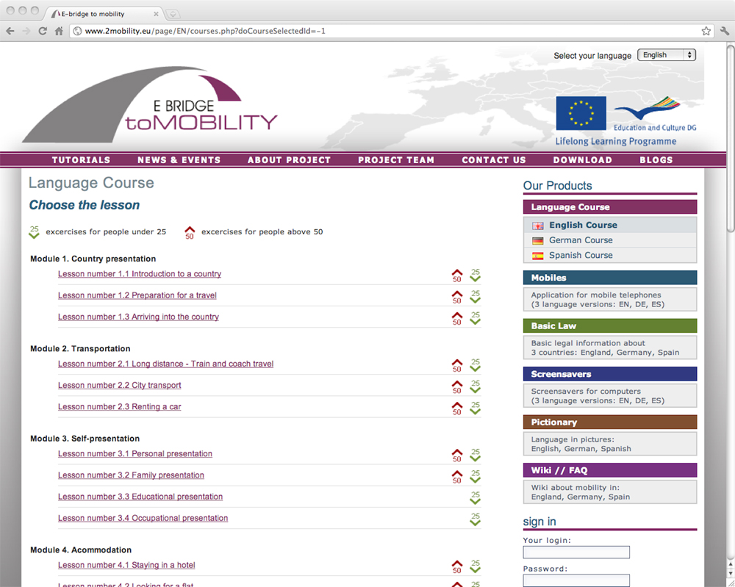

Figure 2.- Language course screen shot

Basic law. This product provides the users with forms and documents that a person changing a country of residence might need. Some of the documents are downloadable, others include a form or printable templates that can be filled in online. “Basic law” is thematically connected with the course, especially with parts concerning communication and official situations requiring the use of official forms. The documents come from three countries: Germany, Spain and the UK. Moreover, the product explains how to use web applications saving data on a server instead of a local computer.
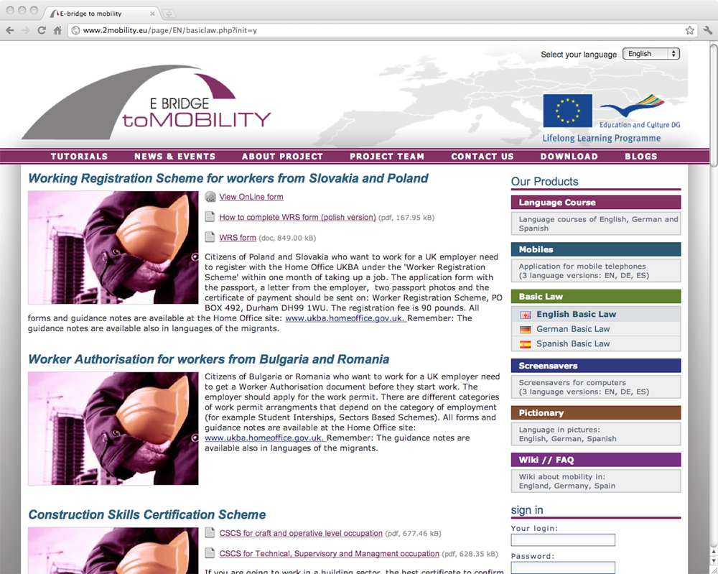
Figure 3.- Basic law screen shot

Screensavers. They were prepared in three language versions and the content is divided into two groups – the first one can be downloaded to a computer and the second one can be 13 downloaded to a mobile phone. The content of screensavers is related to the language course and divided into several thematic modules, such as: Time, In the office, Food, Beverages, On a desk, Basic expressions, Emergencies, Hotel, In the city, Work, Money, Restaurant, Introducing oneself, Trip. Didactic materials were selected so as to secure maximum efficiency. The screensavers contain a dozen or so animated screens connected with the scenarios of the lessons. An additional advantage of these applications is that they can be downloaded to a computer and not necessarily installed as screensavers.

Mobiles. This product is part of the online language course. The applications contain lexical content (vocabulary and phrases) connected with audio files. The whole content is divided into the following topics: Banks and offices, Hotel, Travelling, Basic expressions, Work, Introducing oneself, Restaurant, Meetings, In the city, Emergencies and health, Shopping, Accommodation. The Mobiles product contains the most important information selected from the language course. Therefore, this application, when installed in a mobile phone, can be used either as exercises (to the lessons) or a mobile handbook, independently from the language course. Taking into account that people are using different mobile phones, it is difficult to prepare the contents, so as to make them compatible with different models.

Therefore, the application is shared in two ways: it can be either downloaded directly from a web browser to a mobile phone, or downloaded to a PC from a web page and then transferred to a mobile device via a USB cable, wireless connection, etc.

Pictionary. This product is a glossary in pictures (photos or illustrations), enhanced with audio files presenting pronunciation of words in a particular language. Vocabulary included in the glossary is connected with topics covered by the language course. This product results from experiences gathered by Warsaw Academy during the realization of other language projects.

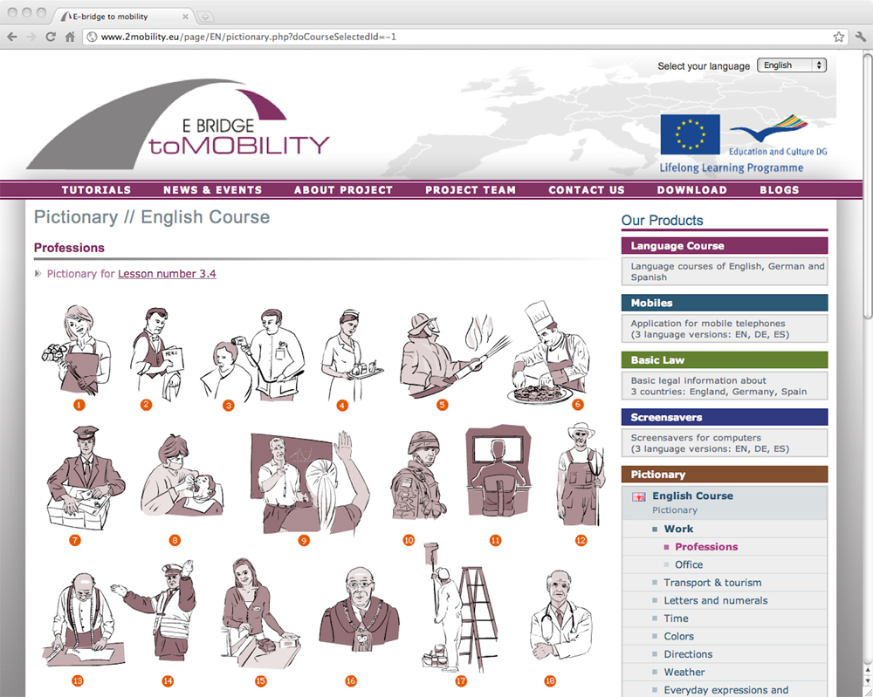
Figure 4.- Pictionary screen shot

The products described above have the following technological characteristics:

1. Language course - Technology: an in-house application based on PHP script language, a MySQL database and an Apache server. Methodological background: e-learning, asynchronous mode. Audio and video materials will be presented with use of in-house applications and scripts using Flash software. Applicability: Computer.
Environment: Internet.

2. Mobile -The applications were prepared for the Symbian operational system, which is installed in majority of new mobile phones offered by companies such as Nokia, Samsung, Motorola, Siemens, Sony Ericsson. Technology: Java Micro Edition, Flash Lite. Methodological background: e-learning. Applicability: Mobile phone.
Environment: for JME applications – all mobile phones manufactured after 2006 for Flash applications – Flash Lite software needs to be installed.

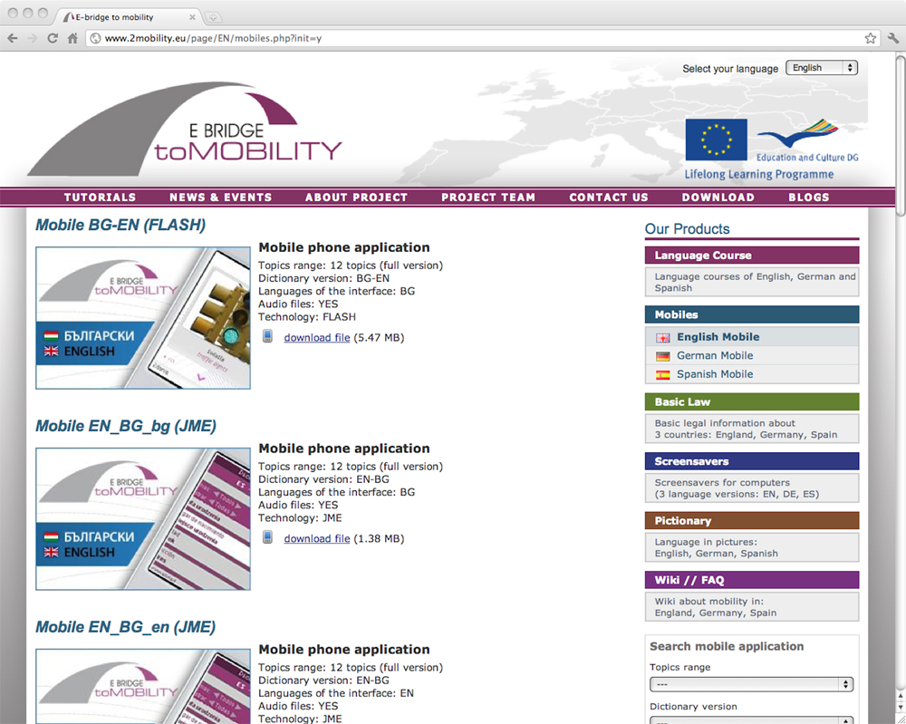
Figure 5.- Mobile screen shot

3. Screensaver - Technology: Flash, InstantStorm. Methodological background: Micro Learning. Applicability: Computer. Environment: Windows operational system.

4. Pictionary - Technology: Flash and HTML. Methodological background: Multimedia learning; Applicability: Computer. Environment: Any operational system in which a browser enabling viewing Flash objects has been installed.

5. Basic Law - Technology: PDF documents, HTML – templates are developed as web applications available only in an online mode. Particular fields of the templates have an open character (text fields) or closed character (select menu). Methodological background: CLIL. Applicability: Computer. Environment: Any operational system, where the Adobe Reader software has been installed.

In order to build an e-community, two functionalities using WEB 2.0. tools were developed:

6. Wiki. This is a functionality of key importance for development of an e-community of people establishing contacts in order to exchange information and opinions thematically connected with the language course (travelling, labour market, health care, flat rental, etc.). Wikis are available in language versions of project partners representing new EU Member States: Bulgarian, Polish, Romanian, Slovak and are moderated by the project partners.

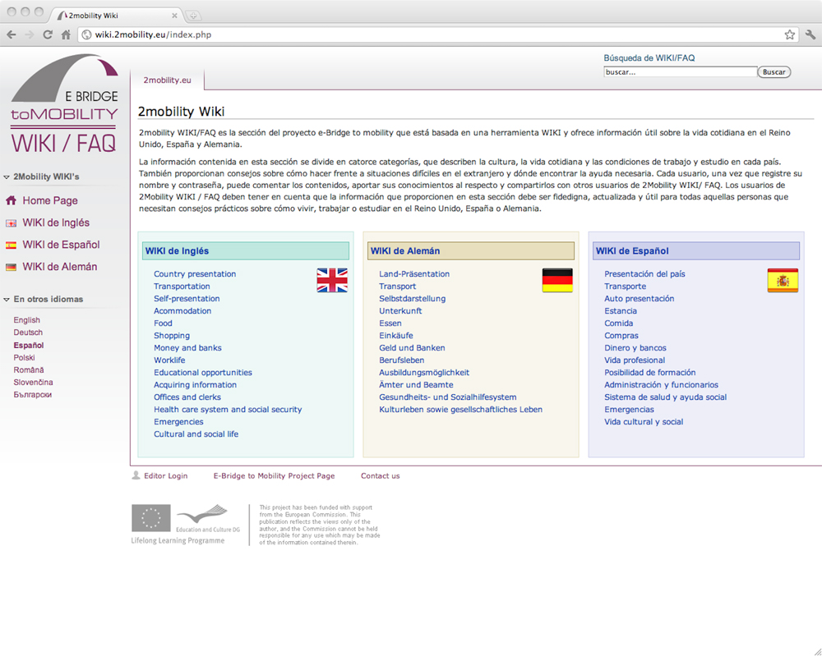
Figure 6.- Wiki/FAQ screen shot

7. Blog. This functionality was made available as the first one and initially it was used to share and comment information about the project without any predefined form. Blogs are written by all the project partners in their national languages.

SOLUTIONS

The purpose of this case is to present the E-bridge to mobility platform (http://www.2mobility.eu) as a real example of non-formal online learning. The aim of this lifelong learning initiative is the personal development of different EU citizens (Colardyn, 2000).

As the European Commission pointed out, adult education is a major instrument against social exclusion (European Commission, 1997, p. 3). Thus, adult education in lifelong learning programmes is a crucial factor for achieving personal development (Colardyn, 2004; Nimmo, 2010).

Non-formal learning (NFE) does not lead to formal qualifications, but it can be organized through formal methodologies (Malcolm et al, 2000; Zepke, 2006). NFE helps young people and adults who have no opportunities to access formal education and, on the whole, creates new ways of employment chances (Weyer, 2009) and life improvement (Shlomo, 2000) in the modern knowledge-based economy.

Researchers show that a much higher number of adults prefer non-formal learning to formal learning, because NFE has significant benefits for their own quality of life (Eraut, 2000; Björnavåld, 2001; Tòtht, 2007) and a sociocultural value (Andersson & Andersson, 2005).

The E-bridge to mobility initiative is a very innovative and creative case of non-formal online learning, which combines formal structure learning, e.g. English, German and Spanish courses, with non-traditional learning, e.g. information about the law system and mobile phone applications.

References
Andersson, S., & Andersson, I. (2005). Authentic Learning in a Sociocultural Framework: a case study on non-formal learning. Scandinavian Journal of Educational Research, 49(4), 419-436.
Björnavåld, J. (2001) Making learning visible: identification, assessment and recognition of nonformal learning, European Journal, Vocational Training, 22, 24–32.
Colardyn, D. (ed.). (2002). Lifelong learning: Which ways forward?. Kenniscentrum EVC, Utrecht: Lemma Publishers.
Colardyn, D., & Bjornavold, J. (2004). Validation of Formal, Non-formal and Informal Learning: policy and practices in EU Member States. European Journal of Education, 39(1), 69-89.
Eraut M. (2000) Non-formal learning and tacit knowledge in professional work. British Journal of Educational Psychology, 70, 113–136.
European Commission. (1997, July). Adult education in the Socrates Programme. Paper presented at the UNESCO Fifth International Conference on Adult Education Confitea V, Hamburg.
European Commision (2004). Eurostat EU Labour Force Survey. Brussels: EU.
European Commision (2006). Eurobarometer Survey Europeans & Mobility: First Results. Brussels: EU.
European Commission (2006a). Report on the Functioning of the Transitional Arrangement set out in the 2003 Accession Treaty. Brussels: EU.
Malcolm, J., Hodkinson, P. and Colley, H. (2003). The interrelationships between informal and formal learning. Paper for International Conference of Researching Work and Learning, Tampere, July 2003.
Nimmo, J. (2010). Learning life. Adults Learning, 21(10), 28-29.
Roosmaa. E.-L., & Saar, E. (2010). Participating in non-formal learning: patterns of inequality in EU-15 and the new EU-8 member countries. Journal of Education & Work, 23(3), 179-206,
Shlomo, R. (2000). Distance Learning and Non-formal Education: Existing Trends and New Possibilities of Distance Learning Experiences. Educational Media International, 37(1), 39-44.
Tóth, J.S. (2007). Documenting and analysing the results of non-formal adult education: the Hungarian Experience. Convergence, 40(3/4), 105-113.
Wever, F. (2009). Non-formal education, out-of-school learning needs and employment opportunities; evidences from Mali. Compare: a Journal of Comparative & International Education, 39(2), 249-262.
Zepke, N., & Leach, L. (2006). Improving learner outcomes in lifelong education: formal pedagogies in non-formal learning contexts?. International Journal of Lifelong Education, 25 (5), 507-518.

Keywords
Non-formal learning, online learning, e-bridge to mobility, lifelong learning programme.

