- Abstracts
  - What? An abstract is a short statement or summary of your paper. It is at the beginning and includes your main points, your thesis, and any conclusions. It is usually written last, after your paper is finished.
  - An abstract appears on the Internet, in searches, etc.
  - For example, this paper (Yashima, 2002) is one I’ve quoted extensively.
  - Let’s visit Google Scholar or Google Scholar in Japanese
  - Here, of course, you can search for specific articles, authors, or subjects…
  - First, open a new Word document; next, find and copy the abstracts for the following three articles:
MacIntyre, P. D. (2007) Willingness to communicate in the second language: Understanding the decision to speak as a volitional process. The Modern Language Journal, 91(4), 564-576.
Root, T. L., Price, J. T., Hall, J. R., Schneider, S. H., Rosenzweig, C., & Pounds, J. A. (2003, January 2). Fingerprints of global warming on wild animals and plants. Nature, 421(6918), 57-60.
Shizuka, T., Takeuchi, O., Yashima, T., & Yoshizawa, K. (2007). A comparison of three- and four-option English tests for university entrance selection purposes in Japan. Language Testing, 23(1), 35-57.
  - Next, can you get the actual article? If so, please download the three articles.
  - A pdf of more abstract examples…
  - Student abstract examples…
The Vocational Education Program in Bolivia
This paper reports on a recent project for Vocational Education implemented in Bolivia during the past five years. The experimental project, based on a similar foreign program, was a failure because it was not adapted to Bolivians’ needs. This report evaluates the failure of the original project, demonstrates that the basic tenets of the plan were positive, and proposes adaptations to the project that will lead to a fine Vocational Educational system

The Effects of Carbon Monoxide
In this paper, the mechanism of carbon monoxide is described and the chemistry of carbon monoxide is presented. The most important aspect of carbon monoxide is examined: its possible catastrophic effects on the global environment. Some specific examples of these effects include those on the human fetus and heart, on vegetation, and on animals.

  - The form… The form is generally slightly different than the rest of the paper, but there is no one standard form. You may, for example, use italics. However, please do indent the abstract 1cm on both the left and right sides.
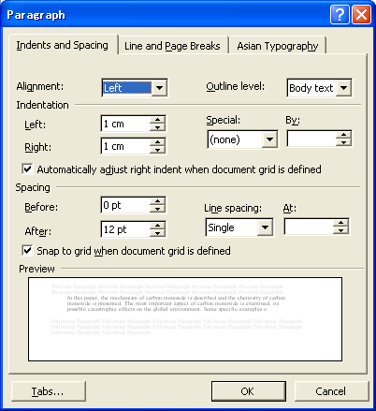
  - Note the absence of “I”… what is the grammar used above?
  - Your job: on your group persuasive paper, you must have an abstract.
  - After we talk about our upcoming schedule (see below), you may work on your group persuasive papers.

